**SPATIOTEMPORAL ANALYSIS OF SHORELINE DYANMICS AND COASTAL VULNERABILITY MAPPING USING GIS AND REMOTE SENSING FOR THE TUTICORIN COAST, TAMIL NADU**

A PROJECT REPORT

*Submitted by*

**MUTHAMILKANI A**

**ROHIT THANUSH K**

**SHRILOKESH U S**

**EUJIN VETHA SANGEETH B**

*In partial fulfillment of the award of the degree*

*Of*

**BACHELOR OF ENGINEERING**

IN

GEOINFORMATICS ENGINEERING



**DEPARTMENT OF CIVIL ENGINEERING**

**ANNA UNIVERSITY REGIONAL CAMPUS TIRUNELVELI**

**ANNA UNIVERSITY: CHENNAI 600 025**

**MAY – 2025**

**ANNA UNIVERSITY: CHENNAI 600 025**

**BONAFIDE CERTIFICATE**

Certified that this project report “**SPATIOTEMPORAL ANALYSIS OF SHORELINE DYANMICS AND COASTAL VULNERABILITY MAPPING USING GIS AND REMOTE SENSING FOR THE TUTICORIN COAST, TAMIL NADU”** is the bonafide work of “**MUTHAMILKANI A(950021135031), ROHIT THANUSH K (950021135035), SHRILOKESH U S (950021135036), EUJIN VETHA SANGEETH B (950021135703)**” who carried out the project work under my supervision.

|  |  |
| --- | --- |
| **Dr. S. ADISHKUMAR, M.E., Ph.D.,**  **HEAD OF THE DEPARTMENT,**  Assistant Professor,  Department of Civil Engineering,  Anna University Regional Campus,  Tirunelveli – 627 007. | **Mrs. C. JAYALAKSHMI, B.E., MTech.,**  **SUPERVISOR,**  Assistant Professor,  Department of Civil Engineering,  Anna University Regional Campus,  Tirunelveli – 627 007. |

Submitted for the VIVA–VOCE Examination held on

|  |  |
| --- | --- |
| **INTERNAL EXAMINER** | **EXTERNAL EXAMINER** |

# ACKNOWLEDGEMENT

First and foremost, we immensely thank **God Almighty** for showering his grace and blessings for the successful completion of this project.

We would like to thank our Joint Research Supervisor **Dr.C. Lakshumanan**, Professor & Head, Department of Remote Sensing, Bharathidasan University, Tiruchirappalli-23, for his valuable guidance, continuous encouragement and all the useful discussions. His deep insights and kind hearted approach helped us at various stages for the successful completion of our project work.

We would like to thank **Dr. Shenbaga Vinayaga Moorthi M.E., Ph.D.**, the dean of the Anna University Regional Campus Tirunelveli.

We wholeheartedly thank **Dr.S. Adishkumar, M.E., Ph.D**., Head of the Department of Civil Engineering, Anna University Regional Campus, Tirunelveli.

We are grateful to **Mrs.C. Jayalakshmi, B.E., MTech.,** Assistant Professor, Department of Civil Engineering, Anna University Regional Campus Tirunelveli for his guidance, knowledge sharing and valuable suggestions to complete the project work.

We have deep gratitude towards **Mrs.G. Devi, MTech.**, our Project coordinator, for her excellent support, valuable suggestions and constant support to complete the project.

Finally, we would like to thank our beloved parents and friends for their unwavering support and encouragement needed throughout the enriching project.

# ABSTRACT

This study presents a comprehensive spatiotemporal analysis of shoreline dynamics, land use/land cover (LU/LC) changes, and coastal vulnerability along the Tuticorin coast of Tamil Nadu, India. The region, located along the Gulf of Mannar, has undergone significant environmental and anthropogenic transformations over the past two decades. Utilizing multi-temporal satellite imagery (2005–2024), GIS tools, and the Digital Shoreline Analysis System (DSAS v5), the research quantifies shoreline changes using key metrics such as End Point Rate (EPR), Linear Regression Rate (LRR), and Net Shoreline Movement (NSM). The results reveal widespread shoreline erosion in areas like Hare Island, Vembar, and Manapad, while accretion is prominent near Tuticorin Port and Tiruchendur largely influenced by sediment transport disruptions due to infrastructure development.

Parallelly, LU/LC classification using Landsat data indicates a marked increase in urban and plantation areas at the cost of agricultural land, scrublands, and ecologically sensitive zones like mangroves and sand dunes. Urban land cover nearly doubled from 2005 to 2024, signalling increasing anthropogenic pressure and habitat loss. These land changes, when integrated with physical and socio-economic parameters into the Coastal Vulnerability Index (CVI), highlight high to very high vulnerability in urbanized and low-lying settlements including Tuticorin, Kayalpattinam, and Tiruchendur. The findings underscore the urgent need for sustainable coastal zone management that balances development with ecosystem preservation. Strategic interventions such as mangrove restoration, shoreline protection measures, land-use regulations, and community-based adaptation planning are vital for enhancing resilience.

# TABLE OF CONTENTS

|  |  |  |
| --- | --- | --- |
| **CHAPTER** | **TITLE** | **PAGE NO** |
|  | **ACKNOWLEDGEMENT** | III |
|  | **ABSTRACT** | V |
|  | **TABLE OF CONTENTS** | VI |
|  | **LIST OF FIGURES** | IX |
|  | **LIST OF TABLES** | X |
|  | **ABBREVIATIONS** | XI |
| **1** | **INTRODUCTION** | 1 |
|  | 1.1. GENERAL | 1 |
|  | 1.2. BACKGROUND | 2 |
|  | 1.3. TYPES OF SHORELINE CHANGES | 3 |
|  | 1.4. AIM AND OBJECTIVE | 4 |
|  | 1.5. NEED FOR THE STUDY | 2 |
|  | 1.6. CONCLUSION | 3 |
| **2** | **LITERATURE REVIEW** | 4 |
|  | 2.1. GENERAL | 4 |
|  | 2.2. REVIEW OF LITERATURE | 4 |
|  | 2.3. CONCLUSION | 11 |
| **3** | **STUDY AREA AND ITS DESCRIPTION** | 12 |
|  | 3.1. GENERAL | 12 |
|  | 3.1.1. LOCATION OF STUDY AREA | 12 |
|  | 3.1.2. DESCRIPTION OF THE STUDY AREA | 14 |
|  | 3.1.3. TOPOGRAPHY OF THE STUDY AREA | 14 |
|  | 3.1.4. CLIMATE OF THE STUDY AREA | 16 |
|  | 3.1.5. PHYSIOGRAPHY | 16 |
|  | 3.1.6. NATURAL RESOURCE & LANDUSE | 17 |
|  | 3.2. CONCLUSION | 17 |
| **4** | **MATERIALS AND METHODOLOGY** | 19 |
|  | 4.1. GENERAL | 19 |
|  | 4.2. DATA USED | 19 |
|  | 4.3. DATA DESCRIPTION | 21 |
|  | 4.3.1. DEM | 21 |
|  | 4.3.2. LANDSAT | 21 |
|  | 4.3.3. BASEMAP | 22 |
|  | 4.3.4. DRAINAGE | 23 |
|  | 4.3.5. SLOPE & ELEVATION | 23 |
|  | 4.3.6. SOIL | 23 |
|  | 4.3.7. LITHOLOGY | 24 |
|  | 4.3.8. GEOMORPHOLOGY | 24 |
|  | 4.3.9. SEA LEVEL CHANGE RATE | 24 |
|  | 4.3.10. WAVE HEIGHT | 25 |
|  | 4.3.11. TIDAL RANGE | 25 |
|  | 4.3.12. SOCIO-ECONOMIC DATA | 25 |
|  | 4.4. SOFTWARES USED | 26 |
|  | 4.4.1. ARCGIS DESKTOP | 26 |
|  | 4.4.2. DSAS V5 | 26 |
|  | 4.4.3. GOOGLE EARTH PRO | 27 |
|  | 4.5. METHODOLOGY | 27 |
|  | 4.6. DATA PROCESSING | 28 |
|  | 4.6.1. FCC IMAGE CREATION | 28 |
|  | 4.7. SHORELINE EXTRACTION | 29 |
|  | 4.7.1. SHORELINE CHANGE RATE ANALYSIS USING DSAS | 29 |
|  | 4.8. LANDUSE & LAND COVER (LULC) CLASSIFICATION | 31 |
|  | 4.9. COASTAL VULNERABILITY INDEX | 31 |
|  | 4.10. CONCLUSION | 32 |
| **5** | **RESULTS AND DISCUSSION** | 33 |
|  | 5.1. GENERAL | 33 |
|  | 5.2. STUDY AREA EXTRACTION | 33 |
|  | 5.3. BASEMAP | 34 |
|  | 5.4. DRAINAGE MAP | 35 |
|  | 5.5. SLOPE MAP | 38 |
|  | 5.6. SOIL MAP | 38 |
|  | 5.7. LITHOLOGY MAP | 41 |
|  | 5.8. GEOMORPHOLOGY MAP | 42 |
|  | 5.9. SHORELINE CHANGE | 44 |
|  | 5.10. LANDUSE & LAND COVER CHANGE DETECTION | 55 |
|  | 5.11. COASTAL VULNERABILITY INDEX | 63 |
|  | 5.12. CONCLUSION | 71 |
| **6** | **CONCLUSION** | 72 |
| **7** | **RECOMMENDATIONS** | 73 |
|  | **REFERENCES** | 76 |

# LIST OF FIGURES

|  |  |  |  |  |
| --- | --- | --- | --- | --- |
| **FIGURE NO.** | | **TITLE** | **PAGE NO.** | |
| 3.1 | Study Area | | | 13 | |
| 4.1 | Methodology | | | 28 | |
| 5.1 | Study Area | | | 34 | |
| 5.2 | Base Map | | | 35 | |
| 5.3 | DRAINAGE MAP | | | 36 | |
| 5.4 | SLOPE MAP | | | 38 | |
| 5.5 | SOIL MAP | | | 39 | |
| 5.6 | Lithology Map | | | 41 | |
| 5.7 | GEOMORPHOLOGY MAP | | | 43 | |
| 5.8 | SHORERLINE MAP | | | 45 | |
| 5.9 | Shorelines | | | 46 | |
| 5.10 | EPR Map | | | 47 | |
| 5.11 | LRR Map | | | 49 | |
| 5.12 | NSM Map | | | 50 | |
| 5.13 | 2035 Shoreline Map | | | 52 | |
| 5.14 | 2045 Shoreline Map | | | 53 | |
| 5.15 | 2005 LU/LC Map | | | 56 | |
| 5.16 | 2015 LU/LC MAP | | | 57 | |
| 5.17 | 2024 LU/LC Map | | | 58 | |
| 5.18 | LU/LC Change Detection Graph | | | 59 | |
| 5.19 | Significant Wave Height Map | | | 61 | |
| 5.20 | Tidal Range Map | | | 62 | |
| 5.21 | Sea Level Change Rate Map | | | 63 | |
| 5.22 | Population Density Map | | | 64 | |
| 5.23 | Literacy Rate Map | | | 65 | |
| 5.24 | Below Age 6 Density Map | | | 66 | |
| 5.25 | Household Map | | | 68 | |
| 5.26 | Coastal Vulnerability Index Map | | | 70 | |

# LIST OF TABLES

|  |  |  |
| --- | --- | --- |
| **TABLE NO.** | **TITLE** | **PAGE NO.** |
| 4.1 | Dataset | 21 |
| 5.1 | LU/LC Area Calculation | 59 |

# ABBREVATIONS

|  |  |
| --- | --- |
| DSAS | Digital Shoreline Analysis System |
| ArcGIS | Aeronautical Reconnaissance Coverage Geographical Information System |
| GIS | Geographic Information System |
| DEM | Digital Elevation Model |
| OLI | Operational Land Imager |
| SRTM | Shuttle Radar Topography Mission |
| FCC | False Colour Composite |
| SOI | Survey of Indi |
| RS | Remote Sensing |
| MSL | Mean Sea Level |
| TIRS | Thermal Infra-Red Sensor |
| CVI | Coastal Vulnerability Index |
| IMSD | Integrated Mission for Sustainable Development |
| NRSC | National Remote Sensing Centre |
| USGS | United States Geological Survey |
| EPR | End Point Rate |
| LRR | Linear regression Rate |
| NSM | Net Shoreline Movement |
| SLCR | Sea Level Change Rate |
| USGS | United States Geological Survey |

**CHAPTER 1**

# INTRODUCTION

## GENERAL

Coastal zones represent some of the most dynamic and productive ecosystems on the planet, acting as vital interfaces between terrestrial and marine environments. These regions support an array of socio-economic activities including agriculture, fishing, tourism, urban development, and industry. However, the growing pressure from natural processes such as wave action, sea-level rise, and sediment transport, compounded by human interventions like construction and resource extraction, have rendered many coastal areas increasingly vulnerable to degradation. One of the most critical manifestations of this vulnerability is shoreline erosion the gradual landward retreat of the coastline due to the loss of sediments.

Shoreline erosion refers to the landward retreat of the coastline due to the removal of beach or dune sediments by wave action, tidal currents, or human activities. This process can result in the loss of valuable land, destruction of habitats, and threats to infrastructure and livelihoods. Understanding and monitoring shoreline erosion are crucial for sustainable coastal management.

Shoreline erosion is not a uniform process; it manifests in diverse forms and at varying rates depending on the specific geological, oceanographic, and climatic conditions of a region.

Shoreline change monitoring refers to the act of keeping track of changes in shorelines over time. Measuring the difference between past and present shorelines can help research to predict future changes in the shoreline – these predictions are important for preservation of potential hotspots and for identifying potentially dangerous situations for citizens.

The Tuticorin coast, situated in the Gulf of Mannar along the Tamil Nadu coastline, presents a compelling case study for understanding the complexities of shoreline erosion. This region is characterized by a diverse geomorphology, encompassing sandy beaches, rocky headlands, mudflats, and ecologically significant coral reefs and mangrove forests. The interplay of the monsoon climate, with its distinct wet and dry seasons and associated changes in wave energy and sediment transport, further complicates the coastal dynamics. Moreover, the Tuticorin coast has witnessed significant anthropogenic modifications in recent decades, including the development of major ports, industrial complexes, and aquaculture farms, which have the potential to exacerbate natural erosion processes.

## BACKGROUND

India, with its vast 7,500 km long coastline, is home to numerous areas experiencing rapid coastal transformation. Among these, the Tuticorin (Thoothukudi) coast along the southeastern shoreline of Tamil Nadu has emerged as a significant case study due to its ecological richness and socio-economic importance. This coastal stretch forms part of the Gulf of Mannar, which is not only a biodiversity hotspot but also home to one of India’s only marine biosphere reserves. Despite these ecological credentials, the region has been undergoing notable changes in shoreline configuration, threatening both natural ecosystems and human settlements.

## TYPES OF SHORELINE CHANGES

1. Erosion

The shoreline moves landward (closer inland) because waves, currents, or human activity wear away the coast. It is caused due to strong waves, sea level rise, storms, or construction that messes with natural sediment flow.

1. Accretion

Opposite the erosion shoreline builds out into the sea due to sediment deposition. It is caused due to river input, gentle waves, or man-made structures like groins that trap sand.

1. Shoreline Retreat

A long-term landward movement of the shoreline. It is caused due to usually due to sustained erosion, sea level rise, or loss of sediment supply.

1. Shoreline Advance

A long-term seaward movement of the shoreline. It is caused due to increase in sediment supply, lower sea levels, or artificial land reclamation.

1. Cyclical/Seasonal Changes

The shoreline changes with the seasons (like sandy beaches getting wider in summer and narrower in winter). It is caused due to seasonal wave energy and wind direction shifts.

1. Human-Induced Changes

It is due to stuff like building seawalls, ports, or sand mining. It can either protect the coast or accidentally increase erosion elsewhere.

**Zone-Specific Shoreline Trends**

Vembar to Tharuvaikulam Stretch:  
This coastal segment has shown mixed trends of erosion and accretion. Remote sensing studies reveal persistent shoreline retreat in several pockets, linked to wave dynamics and sediment imbalance.

Thiruchendur and Udankudi Zone:  
The shoreline in this region has shown relatively low erosion rates, with localized retreat observed particularly in the Alwarthirunagiri area. This zone remains sensitive due to its proximity to fishing hamlets and temples.

Hare Island and Harbour Vicinity:  
Significant erosion has been recorded at the tip of Hare Island and near Tuticorin Port. Alterations in natural sediment flow due to breakwaters and port infrastructure have impacted nearby beach stability.

Manapad to Vaippar Coastline:  
Studies have observed high variability in shoreline change along this stretch, with erosion dominating due to coastal currents, offshore sand loss, and reduced riverine sediment supply

## AIM AND OBJECTIVE

The aim is to study the shoreline changes for sustainable coastal management in the Tuticorin coastal zone for 2 decades.

1. To Assess shoreline changes pattern using temporal satellite data and GIS techniques (2005-2024) for Tuticorin coastal stretch, Tamil Nadu.
2. To Analyse the impact of shoreline changes on coastal landuse and land cover dynamics in Tuticorin coastal regions using temporal satellite data.
3. To develop a coastal vulnerability map by integrating multiple factors such as shoreline erosion, sea level rise, landuse, landforms and anthropogenic activities for Tuticorin coastal stretch.

## NEED FOR THE STUDY

The scope of the study includes

1. To identify areas prone to erosion and accretion, helping in sustainable coastal management.
2. Provide aid in mitigating risks from tsunamis, cyclones, and storm surges by predicting vulnerable zones.
3. To support decision-making for coastal infrastructure development while preserving natural habitats.
4. To aid in developing long-term plans such as beach nourishment, seawalls, and mangrove restoration.
5. To provide a scientific basis for coastal regulations, zoning laws, and hazard mitigation planning.

6.To prioritizes regions that require immediate intervention for coastal protection.

## CONCLUSION

This chapter establishes the importance of coastal regions and the growing threats from both natural processes and human activities. It outlines various types of shoreline changes such as erosion, accretion, and retreat. The Tuticorin coast is introduced as a highly dynamic and vulnerable system affected by development and climate pressures. The chapter also defines the objectives and the need for studying shoreline dynamics and coastal vulnerability.

**CHAPTER 2**

# LITERATURE REVIEW

## GENEREAL

The literature review provides a foundation for understanding previous research conducted globally and regionally on shoreline dynamics and coastal vulnerability. It assesses various methodologies like DSAS and CVI used in earlier studies and evaluates their applicability to the Tuticorin context. This review identifies gaps in spatial analysis and socio-environmental integration that this study aims to address.

## REVIEW OF LITERATURE

**Arun P. R. et al.,** (2025), this study investigates the coastal shoreline change in Kozhikode district, due to natural (monsoons, wave activity) and human interventions. Landsat images were acquired and using DSAS tool, LLR, EPR, techniques, the shoreline regions have been divided into five unique categories based on the rates of coastal change determined by LRR values. It's concluded that Erosion is mainly concentrated near river estuaries due to reduced fluvial inflow, with the lack of seawalls and protective structures, which further increased the erosion rate.

**Abdel Azi et al.,** (2024), this Article represents the study on Rosetta shoreline to detect the change in shoreline before and after the installation of protection structures over the period of 43 years. The results of statistical methods SCE, EPR, NSM and LRR calculated by DSAS shows maximum erosion on the eastern and western zones from the built-up protection structures.

**Muhamed Fasil Chettiyam Thodi et al., (2023)**, **t**his study analysed shoreline changes in Vypin, Vallarpadam, and Bolgatty islands (Kerala) from 1973–2019 using the DSAS tool. Statistical methods like Net Shoreline Movement (NSM), End Point Rate (EPR), and Linear Regression Rate (LRR) helped quantify these changes. The study confirms that these coastal islands suffered a greater impact, and accretion on both sides led to the formation of new land on these islands.

**Dwivedi et al., (2023)** used a fuzzy AHP-based Coastal Vulnerability Index to compare the Kerala and Tamil Nadu coasts. Their integrated model considered geological, geomorphic, and social factors. The study found Tamil Nadu’s coast to be more vulnerable due to low elevation and human-induced stresses, providing strong methodological backing for multi-criteria vulnerability assessment.

**Yadav et al. (2022)** assessed the coastal vulnerability of the Ratnagiri coast in Maharashtra, India, by calculating the CVI using eight risk parameters: shoreline change rate, coastal elevation, sea-level change rate, coastal slope, tide range, significant wave height, coastal geomorphology, and tsunami arrival height. The DSAS tool was utilized to determine shoreline change rates, categorizing the coast into high, medium, and low vulnerability zones. This study highlights the significance of integrating multiple geophysical parameters to understand and manage coastal hazards effectively.

**Amandangi Wahyuning Hastuti et al., (2022)**, this study aims to quantitatively assess the vulnerability of the coastal zones of Bali Province to the actual Study Area rate of SLR by developing a CVI, considering the geological and physical characteristics of coastal processes. The study adopts an index-based methodology applying the CVI. CVI represents a combined result of the parameters influencing coastal vulnerability in the coastal area. The data were compiled from various sources to initially build a database of the parameters. This study indicated that geomorphology, shoreline change rate, coastal elevation and significant wave height are the most contributing parameters determining coastal vulnerability.

**Mutagi et al., (2022)** employed Sentinel-2 imagery to monitor shoreline changes in the Karwar region. Through image classification and erosion mapping, the study concluded that mangrove destruction and infrastructure development have altered the natural shoreline equilibrium.

**Das and Dhorde (2022)** analysed the interaction between mangrove vegetation and shoreline dynamics in Raigad, Maharashtra. Their findings show a direct correlation between mangrove loss and increased erosion, validating the significance of LU/LC changes in coastal resilience assessments.

**Haldar et al. (2022)** performed a comparative study on the Purba Medinipur-Balasore coastal stretch, employing both Gornitz's CVI model and the Analytical Hierarchy Process (AHP) to assess physical vulnerability to coastal hazards. The study incorporated parameters such as elevation, slope, bathymetry, coastal geomorphology, shoreline change, and coastal land use, along with physical process variables like mean sea level, tidal range, significant wave height, and storm surge height. The analysis revealed that 13.56% of the coastline is highly vulnerable according to Gornitz's CVI model, while the AHP model indicated 11.29% high vulnerability. This research underscores the utility of combining empirical models for comprehensive coastal vulnerability assessments.

**Elkafrawy et al., (2021),** this study investigates the effectiveness of coastal structures along the Burullus Headland-Eastern Nile Delta, Egypt using RS and GIS, by dividing the coast into 4 zones. By analysing data from Landsat MSS, TM, ETM, and OLI sensor, histogram threshold values where applied to derive shorelines. By using the DASA tool and EPR method, the result obtained shows zones of high erosion and accretion. The result predicted that there will be potential for erosion to happen in 2 of the four zones in 2030.

**Muthusankar G et al., (2021)**, this study focuses on multi-hazard risk assessment and coastal zone management in the Nagapattinam coast, Tamil Nadu. The research uses geospatial techniques and hazard mapping to assess risks from sea-level rise, cyclones, storm surges, and saline water intrusion. The authors employed methodologies such as the Coastal Vulnerability Index (CVI), static inundation modelling (1–5 meters SLR), and GALDIT model to evaluate aquifer vulnerability. The results indicate that certain coastal stretches are at high risk due to low elevation, lack of natural buffers, and human interventions. The study also provides a multi-hazard zonation map and recommends adaptive management strategies for sustainable coastal development and disaster risk reduction.

**Sathiya Bama et al., (2020),** conducted a study on the Vedaranyam swamp coast using DSAS and LU/LC analysis to assess coastal vulnerability. Using Landsat images and shoreline metrics like EPR and NSM, the study concluded that shoreline changes and land use transformations significantly contribute to hazard risk. Their results underline the urgency of regulating development near eroding shorelines.

**Kumar et al. (2019)** conducted a comprehensive study on the Tuticorin coast of Tamil Nadu, India, utilizing Landsat satellite imagery from 1978 to 2017 to analyse shoreline changes. The DSAS tool was employed to calculate shoreline change rates, revealing significant erosion in areas such as Vembar and Periyasamypuram, and accretion near Muttayyapuram due to sediment deposition from the Thamiraparani estuary. Six physical variables geomorphology, shoreline change rate, coastal slope, relative sea-level change, mean wave height, and mean tide range were integrated to compute the CVI. The resulting vulnerability map categorized the coastal zones from low to very high vulnerability, providing valuable insights for coastal management and disaster mitigation strategies.

**Mirna Sebat et al., (2018),** the study mainly, depended on high -resolution satellite image (1m) Of (Ikonos) type, taken in 2010 referent and geographically projection. The shoreline change rate is calculated with the most commonly used being End Point Rate (EPR).The integration of modern technology today and remote sensing with geographic information system (GIS) demonstrated a great ability to give useful approach to study the shoreline changes.

**Sudha Rani et al., (2015)** reviewed coastal vulnerability studies across India, emphasizing the need for integrated coastal risk mapping. The study reinforced the use of CVI, LRR, and EPR as effective tools to identify zones needing protection, offering a valuable comparative baseline for Tamil Nadu.

**Kankara R.S. et al.,** **(2015),** this study focusses on analysing the long- and short-term shoreline changes of the Andhra Pradesh coastline using GIS techniques from the remote sensing data. The short term change analysis was done by using EPR techniques, while the long term change analysis were computed using multi dated shorelines. A weightage value is added in Weighted Linear Regression (WLR) method for identifying the long-term shoreline analysis.

**Siva Sankari et al., (2015),** In this study the coastal vulnerability index (CVI) has been used to map the relative vulnerability of the study area and characterize the vulnerability of the coast due to coastal processes and human activities. The study area is particularly selected because this area is highly affected during the 2004 tsunami and are highly vulnerable any natural disasters. The methodology used for the study is the methodology adopted by Theiler and Hammer Close. Each parameter used in the study was given individual rank and weightage.

**Usha Natesan et al., (2015)**, this article investigates the shoreline change along the coast of Tamil Nadu by diving the coast into 4 zones. The Erosion/Accretion analysis of these shorelines were done using techniques like LLR and EPR. The obtained erosion and accretion rates for Tamil Nadu coast were divided into 7 categories varying from moderate to very high erosion/accretion and stable. Based on the shoreline change rate the entire coast is classified into seven categories such as high erosion, medium erosion, low erosion, stable, high accretion, medium accretion and low accretion.

**Sheik Mujabar et al.,** (2013), in this study, the erosion hazard and vulnerability of southern coastal Tamil Nadu of India have been estimated and analysed. The study area is the coast between Kanyakumari and Tuticorin, the shoreline along the study area is classified on the basis of the relative coastal vulnerability index(CVI). The vulnerability determined here focuses on six variables, as the analysis reveals that both geological and physical variables have involved in the modification of the coast along the study area.

**ArunKumar and Kunte (2012)** assessed the Chennai coast using geospatial tools and developed a CVI integrating slope, geomorphology, wave height, and population density. The study focuses on a 56-km stretch of the Chennai coastline, employing geospatial tools to develop a Coastal Vulnerability Index (CVI). Eight variables were considered: shoreline change rate, mean sea-level change rate, regional elevation, near-shore bathymetry, mean tidal range, significant wave height, coastal geomorphology, and extreme storm surge. The analysis revealed that 11.01 km of the coastline is of low vulnerability, 16.66 km is of medium vulnerability, and 27.79 km is highly vulnerable. The resulting vulnerability map serves as a valuable tool for disaster mitigation and coastal management planning.

**Hammar-Klose et al. (2003)** focused on assessing the vulnerability of Cape Cod National Seashore in Massachusetts to sea-level rise using the CVI framework. The study considered factors including geomorphology, coastal slope, relative sea-level rise, shoreline change rates, tidal range, and wave height. Results showed that areas with low-lying beaches and unconsolidated sediments, particularly along Cape Cod Bay, were more susceptible to sea-level rise impacts. Conversely, regions with steep glacial cliffs exhibited lower vulnerability. This assessment provided valuable insights for park management and long-term planning.

**Thieler and Hammar-Klose (1999)** conducted a preliminary assessment of the U.S. Atlantic Coast's vulnerability to sea-level rise using the Coastal Vulnerability Index (CVI). The study incorporated six variables: geomorphology, coastal slope, relative sea-level rise rate, shoreline erosion/accretion rates, mean tidal range, and mean wave height. The analysis revealed that the Mid-Atlantic region, particularly the Delmarva Peninsula, exhibited high vulnerability due to low elevation and high erosion rates. This assessment provided a foundational understanding of regional vulnerabilities along the Atlantic seaboard.

## CONCLUSION

This chapter surveys global and regional studies on shoreline change and coastal vulnerability. It highlights the relevance of tools like DSAS, CVI, and satellite data in quantifying shoreline dynamics. The review reinforces the importance of integrating physical and socio-economic parameters for risk assessment. It also identifies gaps in prior studies that this thesis aims to address for the Tuticorin region.

# CHAPTER - 3

# STUDY AREA AND ITS DESCRIPTION

## GENERAL

This chapter offers a comprehensive description of the Tuticorin coastal region, focusing on its geographical location, physiography, and climatic conditions. It highlights the presence of ecologically sensitive features like mangroves, coral reefs, and salt pans. These physical characteristics make the area both environmentally rich and highly susceptible to natural hazards like sea-level rise and erosion.

### LOCATION OF STUDY AREA

Thoothukudi District is one of the 38 districts of Tamil Nadu state in southern India. The total area of the district is 4,621 km2. The district lies in the southeastern corner of Tamil Nadu, bounded by Virudhunagar and Ramanathapuram districts to the north, the Bay of Bengal to the east, and Tirunelveli district to the west and southwest. The Thoothukudi coastline stretches around 162 km, located in the Southern tip of the Gulf of Mannar. The study area is situated between 8°19’25.30"N and 9°07’20.68"N latitude, and 77°49’40.64"E and 78°22’02.56"E longitude.

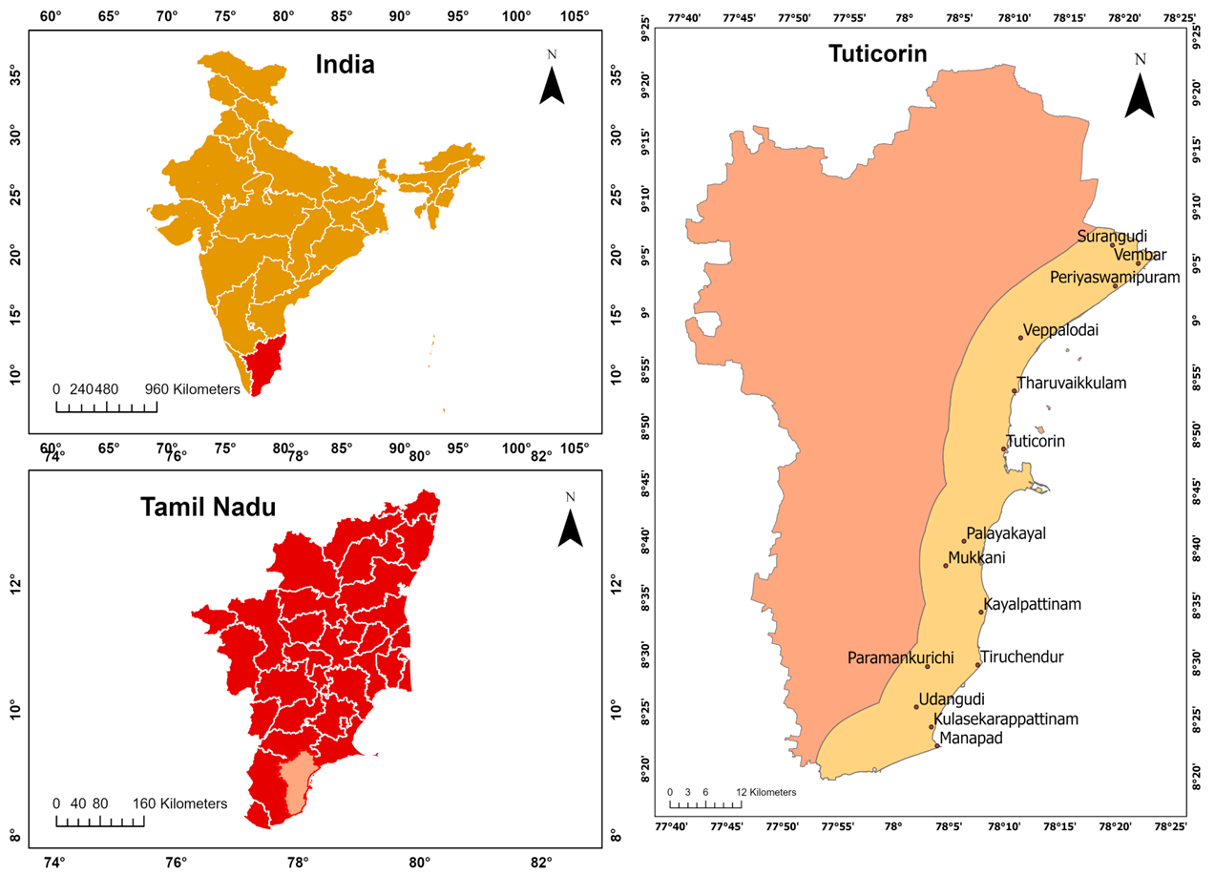

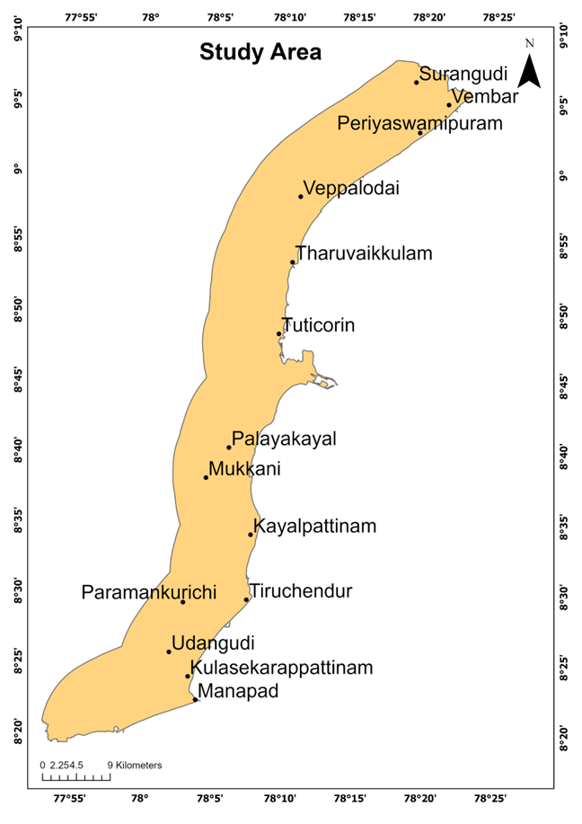

Figure 3.1 Study Area

### DESCRIPTION OF THE STUDY AREA

The district has water bodies connected to various river basins, including the Gundar River Basin, Kallar River Basin, Nambiyar River Basin, Tamirabarani River Basin, and Vaippar River Basin.

The coastline is characterized by a long, curvy stretch featuring sandy beaches, rocky outcrops, and ecologically important areas like coral reefs and mangrove forests within the Gulf of Mannar Biosphere Reserve. The terrain is generally flat, with sandy coastal alluvium in the east transitioning to red and black soil in the western parts. The district experiences a tropical climate with hot and humid summers, a gentler winter, and rainfall mainly during the northeast monsoon. Key rivers in the district include the Thamirabarani, Vaippar, and Karumeni. Several islands are located off the Thoothukudi coast in the Gulf of Mannar.

### TOPOGRAPHY OF THE STUDY AREA

1. Flat Coastal Plains:

The region predominantly consists of flat to gently sloping coastal plains, extending inland for several kilometers. These plains are formed by marine and fluvial processes and are highly susceptible to coastal erosion and flooding.

1. Low Elevation:

Most of the Tuticorin district lies at elevations below 30 meters above sea level. Coastal zones, especially near the port and fishing villages, often lie just 1–5 meters above sea level, making them particularly vulnerable to sea-level rise and storm surges.

1. Marine and Aeolian Features:

The coastal stretch features sandy beaches, sand dunes, tidal flats, and mudflats. In some areas, aeolian (wind-blown) sand deposits form small dunes, especially near salt pans and barren stretches.

1. Backwaters and Lagoons:

The region has coastal wetlands, shallow lagoons, and backwater systems, particularly around areas like the Korampallam Creek. These features contribute to ecological richness and also influence local sedimentation and drainage patterns.

1. Coral Islands and Reefs (Offshore):

Off the coast, the Gulf of Mannar includes 21 coral reef islands, of which some like Vaan, Kaswar, and Kariyachalli fall near Tuticorin. These islands and reefs influence wave patterns, sediment distribution, and coastal erosion dynamics.

1. Salt Pans and Estuarine Terrain:

Large expanses of man-made salt pans dominate the coastal hinterland, often developed on low-lying alluvial and marine sediments. These flat surfaces further emphasize the level terrain of the region.

1. Riverine Influence:

The Tamirabarani River enters the sea near Punnaikayal (north of Tuticorin) and contributes to local sedimentation and estuarine landforms. Seasonal variations in river discharge affect sediment supply to the coast.

### CLIMATE OF THE STUDY AREA

Tuticorin (Thoothukudi) experiences a hot, semi-arid tropical climate, characterized by high temperatures, moderate humidity, and limited rainfall. Summers (March to June) are particularly intense, with temperatures ranging from 30°C to 40°C, while winters (December to February) are milder, averaging between 22°C and 30°C. The region receives an average annual rainfall of 600–700 mm, primarily during the northeast monsoon from October to December, while the southwest monsoon contributes minimally due to the rain-shadow effect of the Western Ghats. Humidity levels typically range from 60% to 80%, and strong coastal winds prevail throughout the year, influencing sediment transport and shoreline dynamics. Though not frequently hit by cyclones, Tuticorin is vulnerable to storm surges and extreme weather events originating in the Bay of Bengal. Recent climate change trends, such as rising sea levels and changing wind and wave patterns, further exacerbate coastal erosion risks, making climate a critical factor in the region’s shoreline changes.

### PHYSIOGRAPHY

Tuticorin District displays diverse physiographic features categorized into five major landform units. The Coastal Plains are flat, low-lying areas along the Gulf of Mannar, with elevations ranging from 0 to 5 meters. These areas are characterized by sandy beaches, salt pans, mudflats, and coastal dunes, supporting vital economic activities such as fishing, salt production, and port operations.

Moving inland, the Upland Areas lie mainly in the northwestern region, featuring undulating rocky terrain with elevations between 50 and 200 meters, and are dominated by red and lateritic soils. The Scrub and Dry Lands, found primarily in the north and west, are semi-arid zones with thorny vegetation, making them less suitable for agriculture without proper irrigation. The district also contains significant River Basins, including those of the Thamiraparani, Vaippar, Kallar, Nambiyar, and Gundar rivers, which support a network of tanks and reservoirs essential for irrigation. Lastly, the Salt Pans and Marshlands along the southern coastal belt play a key role in salt farming, making Thoothukudi one of India's leading salt producers, while also serving as wetlands that support rich birdlife and marine biodiversity.

### NATURAL RESOURCE & LANDUSE

Tuticorin District is rich in natural resources, with the southern regions known for their extensive salt pans, making a significant contribution to India’s overall salt production. The fertile plains in various parts of the district support agricultural activities, with key crops including paddies, pulses, and cotton.

Although the district has limited forest cover, it includes patches of scrub and thorn forests, particularly in the drier inland areas. These land uses reflect a balance between economic utilization and the region’s natural ecological characteristics.

## CONCLUSION

Tuticorin district is described with respect to its geography, topography, climate, and natural resources. It features flat low-lying coastal plains, vulnerable to sea-level rise and storm surges. The area is ecologically diverse, with salt pans, mangroves, coral reefs, and estuarine systems. Its socio-economic relevance and geomorphological complexity make it suitable for this coastal vulnerability study.

**CHAPTER 4**

# MATERIALS AND METHODOLOGY

## GENERAL

This chapter details the data sources, remote sensing tools, and GIS techniques used to analyse shoreline dynamics and vulnerability. It outlines the processing steps for shoreline extraction, land use classification, and CVI computation. The integration of physical, environmental, and socio-economic datasets ensures a holistic and accurate coastal assessment.

## DATA USED

The datasets used in this study were selected to support a detailed assessment of coastal processes and vulnerability along the Tuticorin coast. Primary spatial data sources include Landsat imagery for land use/land cover analysis, SRTM DEM for elevation and slope modeling, and Survey of India toposheets for basemap and drainage features. Thematic layers such as soil, lithology, and geomorphology were obtained from national scientific institutions like the Geological Survey of India and ICAR. Additionally, marine and climate data such as sea-level change rate, tidal range, and wave height were sourced from PSMSL and INCOIS. Socio-economic variables including population density, literacy, and household data were retrieved from the Census of India. The use of both physical and social datasets ensures a multi-dimensional perspective on shoreline dynamics and vulnerability. The data used for assessing the Shoreline dynamics are shown in the Table 4.1

|  |  |
| --- | --- |
| **DATASETS** | **SOURCE** |
| Basemap | Survey of India |
| Drainage Map | Survey of India |
| Slope & Elevation | SRTM – DEM, USGS Earth Explorer |
| Soil Map | National Bureau Of Soil Survey and Land Use Planning (ICAR) |
| Lithology | Geological Survey of India |
| Landuse/Land cover | Landsat, USGS Earth Explorer |
| Geomorphology | Landsat, USGS Earth Explorer |
| Sea Level Change Rate | Permanent Service for Mean Sea Level, National Oceanography Centre |
| Wave height | ESSO - Indian National Centre for Ocean Information Services |
| Tidal Range | Permanent Service for Mean Sea Level, National Oceanography Centre |
| Socio-economic parameters | Census of India |

Table 4.1: Dataset

## DATA DESCRIPTION

### DEM

A Digital Elevation Model (DEM) is a 3-Dimensional representation of the topography of a land surface or terrain. DEMs are often used in GIS and are the most common basis for digitally produced relief maps. In the study, we used SRTM (Shuttle Radar Topography Mission) DEM with a 30m spatial resolution to perform slope and elevation. The data was downloaded from the USGS Earth Explorer. SRTM provides elevation values with high precision, allowing for reliable slope calculations.

### LANDSAT

The data for LU/LC were obtained from the Landsat 5 &8 satellite. Landsat 5 was launched by NASA in 1984 and operated until 2013, making it one of the longest-operating Earth observation satellites. It carried two primary sensors: the Thematic Mapper (TM) and the Multispectral Scanner (MSS), which provided data in seven spectral bands across the visible, near infrared, and thermal infrared regions. With a spatial resolution of 30 meters for most bands and a revisit time of 16 days, Landsat 5 was instrumental in monitoring land use, vegetation, water bodies, and coastal changes over nearly three decades. Its consistent data was vital for time-series analysis and change detection, particularly in environmental and urban studies. Despite technological limitations by modern standards, its longevity made it a cornerstone in Earth observation.

Landsat 8, launched in 2013, is a more advanced satellite in the Landsat series, designed to continue the program’s legacy with improved data quality and sensor technology. It carries two sensors: the Operational Land Imager (OLI) and the Thermal Infrared Sensor (TIRS), offering 11 spectral bands, including additional coastal and cirrus bands do not present in earlier missions. With 30-meter spatial resolution (15 meters for the panchromatic band) and a 16-day revisit cycle, Landsat 8 provides high-quality imagery for applications in agriculture, forestry, water resources, and coastal monitoring. Its enhanced radiometric resolution (12-bit) allows for more precise detection of subtle changes on the Earth's surface. Landsat 8 is especially valuable for tracking shoreline dynamics and land cover changes with greater clarity and accuracy.

### BASEMAP

A basemap provides the foundational spatial framework upon which all thematic layers and geospatial analyses are built. It includes critical geographic features such as coastlines, political boundaries, rivers, roads, and settlements. Basemaps ensure accurate alignment and referencing of datasets in GIS environments. They are essential for visualization, location pinpointing, and integrating diverse datasets consistently across scales. The Base map data was obtained from the toposheets of the study area, provided by the Survey of India. The Survey of India is the primary national authority for high-accuracy topographic mapping.

### DRAINAGE

The drainage map data was obtained from the toposheets of the study area, provided by the Survey of India. Drainage maps show the layout of rivers, streams, canals, and catchment areas, which are vital in understanding water flow patterns in a region. In coastal zones like Tuticorin, drainage patterns influence sediment delivery, freshwater input into estuaries, and seasonal flooding. Accurate drainage maps are used in hydrological modelling, water resource management, and flood hazard assessments.

### SLOPE & ELEVATION

Slope and elevation data derived from SRTM (Shuttle Radar Topography Mission) Digital Elevation Models (DEMs) are used to understand terrain variation and landscape gradients. Coastal slope affects how far sea water can intrude inland during high tides or storm surges. Elevation maps help identify low-lying, flood-prone areas and guide infrastructure planning, especially in climate-sensitive coastal zones.

### SOIL

The data for soil map was acquired from National Bureau of Soil Survey and Land Use Planning (ICAR). Soil maps represent the spatial distribution, texture, depth, drainage, salinity, and fertility of different soil types. These characteristics influence agricultural productivity, construction suitability, erosion susceptibility, and coastal vegetation. In coastal management, understanding soil composition helps evaluate sediment budgets, mangrove restoration potential, and land degradation risks. The ICAR soil surveys provide standardized national-level data valuable for both scientific studies and land use planning.

### LITHOLOGY

The data for the lithology map was acquired from the Geological Survey of India. Lithology maps describe the type and structure of rocks and geological formations in an area. This information is critical in coastal studies for assessing the resistance of shoreline material to erosion and weathering. Hard rock coastlines erode slower than sandy or alluvial ones, influencing shoreline stability and change rates.

### GEOMORPHOLOGY

The data for geomorphology was obtained from Landsat-8. Geomorphological maps classify landforms based on surface processes such as coastal erosion, deposition, tidal action, and aeolian activity. These maps identify features like beaches, dunes, estuaries, lagoons, and deltas, which evolve over time due to natural forces.

### SEA LEVEL CHANGE RATE

This dataset tracks the long-term trend of rising or falling sea levels using data from tide gauges and satellite altimetry. In coastal areas like Tuticorin, even small increases in sea level can lead to saltwater intrusion, wetland submergence, and increased flood risks. Monitoring sea level change is essential for climate adaptation planning, infrastructure resilience, and coastal zoning. The Permanent Service for Mean Sea Level (PSMSL), National Oceanography Centre is a global authority providing standardized sea level records from across the world.

### WAVE HEIGHT

The data for wave height was obtained from ESSO-INCOIS. Wave height data indicate the average or maximum height of waves in a given period and location, reflecting oceanic energy and weather patterns. This data is crucial for understanding shoreline erosion, coastal engineering design, and safety of maritime activities. In Tuticorin, changes in wave height patterns can directly impact beach erosion rates, sediment transport, and fishing operations. ESSO-INCOIS provides real-time and historical wave data for Indian coastal waters.

### TIDAL RANGE

The tidal range data was obtained from Permanent Service for Mean Sea Level (PSMSL), National Oceanography Centre. Tidal range is the vertical difference between high and low tide levels and significantly affects coastal flooding, sediment deposition, and inter-tidal ecosystem dynamics. In areas with a large tidal range, coastal erosion and deposition can be more pronounced.

### SOCIO-ECONOMIC DATA

Socioeconomic data includes information on population density, literacy rate, employment, housing, and resource access. In coastal studies, such data is essential to assess human vulnerability, dependence on marine resources, and adaptive capacity to environmental changes. It supports integrated coastal zone management by aligning physical risks with social and economic exposure. The Census of India is the official source of demographic and household data at multiple administrative levels.

## SOFTWARES USED

GIS software are computer-based programs and tools that allows the user to visualize, analyse, interpret and store the geographic datasets. The software that has been for the study are,

1. ArcGIS Desktop
2. DSAS V5 extension
3. Google Earth Pro

### ArcGIS Desktop

ArcGIS is a Desktop software developed by ESRI which can be used primarily to view, edit, create, and analyse geospatial datasets. ArcMap 10.8 has been used in particular, which is a part of the ArcGIS desktop suite. ArcMap is the former main component of ESRI’s ArcGIS suite of geospatial processing programs. ArcMap allows the user to explore data within a data set, symbolize features accordingly, and create maps. The ArcMap interface has two main sections, including the table of contents on the left and the data frames which display the map. Items in the table of contents correspond with the layers on the map.

### DSAS V5

Digital Shoreline Analysis System (DSAS) v5 is a powerful GIS-based tool developed by the U.S. Geological Survey (USGS) to calculate and analyse rates of shoreline change over time. Built as an extension for Esri’s ArcGIS software, DSAS automates the process of deriving shoreline movement statistics from historical shoreline positions digitized from maps, satellite images, or aerial photographs. Version 5 (v5) represents the most recent and enhanced version of this tool.

### GOOGLE EARTH PRO

Google Earth was originally developed at Intrinsic Graphics in the late 1990s. Google Earth Pro is a powerful geospatial mapping tool developed by Google. Designed to provide the requirements of professionals, researchers, and enthusiasts. Google Earth Pro offers a suite of advanced features for complex spatial analysis and visualization tasks. Google Earth provides a series of other tools through the desktop application, including a measure distance tool.

## METHODOLOGY

The methodology mainly focuses in Mapping Shoreline dynamics and Coastal Vulnerability of this study area. The flowchart of methodology is shown in figure 4.1

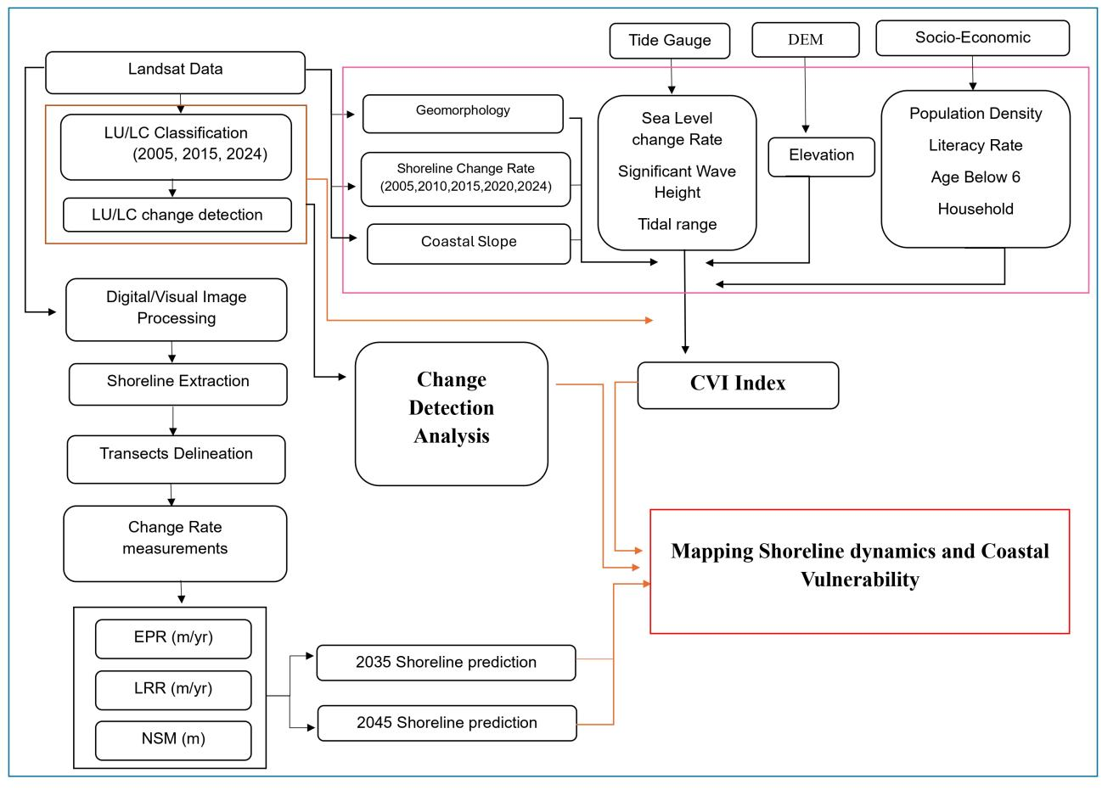

Figure 4.1: Methodology

## DATA PROCESSING

Processing is an important step in remote sensing and image processing that involves preparing and enhancing raw data before it is analysed or used for applications such as image classification or change detection. Pre-processing can involve several techniques to correct various sources of error or to improve the quality of the data.

### FCC IMAGE CREATION

FCC (False Colour Composite) image creation is a process of combining multiple bands of satellite imagery to create a single colour image. The resulting image can provide useful information about the features and conditions on the ground.

The process of creating an FCC image involves selecting three bands of satellite imagery, usually from the visible and near-infrared spectrum. The bands are then assigned to the red, green and blue channels of the image. The resulting image will have colours that are not true to life, but can highlight certain features such as vegetation, waterbodies and urban areas

## SHORELINE EXTRACTION

Shoreline extraction is performed by digitizing the land-water boundary manually (visual interpretation). The output is a set of shoreline vectors for each year (2005, 2010, 2015, 2020, 2024), which serve as the basis for measuring coastal movement.

### SHORELINE CHANGE RATE ANALYSIS USING DSAS

The extracted shoreline vectors are input into the Digital Shoreline Analysis System (DSAS v5), a GIS based tool that computes shoreline change statistics. A baseline is created parallel to the general orientation of the shoreline. Transects are generated perpendicular to the baseline at uniform intervals.

DSAS then calculates various rate-of-change statistics at each transect, including:

1. End Point Rate (EPR) (m/yr): Calculated by dividing the total distance between the oldest and the most recent shoreline positions by the time span. It provides a simple overall rate of change.

EPR = Total Shoreline Movement (distance) / Time Interval (years).

1. Linear Regression Rate (LRR) (m/yr): A statistical method that fits a least-squares regression line through all the shoreline positions for each transect. LRR is considered more robust as it considers all available data points and accounts for variations in change rates over time.

L = b + mx

where L is the distance from a baseline, x is the time interval, m is the slope of the line (representing the shoreline change rate), and b is the y-intercept.

1. Net Shoreline Movement (NSM) (m): The total distance between the oldest and the most recent shoreline positions along a transect, indicating the net erosion or accretion.

NSM = Sn​−S1​

Where, Sn​ = Position of the most recent shoreline

S1​ = Position of the earliest shoreline

These metrics are used to identify areas experiencing significant erosion or accretion and help quantify the severity and extent of shoreline change.

2035 and 2045 Shoreline Prediction: Based on the calculated shoreline change rates (likely using the LRR or other predictive models), future shoreline positions for the years 2035 and 2045 are predicted. This helps in understanding the potential future extent of erosion or accretion and planning for future coastal management.

## LANDUSE/LAND COVER (LULC) CLASSIFICATION

Land cover is simply what covers the earth's surface and land use describes how the land is used. Landuse/Land Cover (LULC) is a valuable indicator for tropical cyclone vulnerability assessment.

In this study, Landuse/Land Cover (LULC) classification for the year 2005, 2015, 2024 were carried out using manual visual interpretation of satellite imagery obtained from Landsat data. Using visual cues such as colour, texture, shape, location, and pattern, 14 major LULC categories were identified: Crop Land, Fallow Land, Land Without Scrub, Land With Scrub, Mangroves, Mud Flat, Plantation, Rural, Saltpan, Sand Area, Scrub Forest, Terai Sand, Urban, and Water Body. This classification approach was particularly effective in a heterogeneous and dynamic coastal environment like Tuticorin, where automated classification often struggles with mixed pixels and spectral confusion due to similar reflectance values across land cover types. Manual interpretation allowed for expert judgment in identifying contextual relationships and fine-scale features, thereby enhancing classification accuracy. The final LULC map was prepared in a GIS environment, and each class was cross validated using available secondary data, Google Earth overlays, for ensuring thematic accuracy.

## COASTAL VULNEURABILITY INDEX

The Coastal Vulnerability Index (CVI) is a method used to assess and map the relative vulnerability of different coastal segments to shoreline change, sea-level rise, and other coastal hazards. In the methodology shown, the CVI is derived by integrating various physical and socioeconomic parameters that influence coastal sensitivity. Once each section of the coastline has been assigned a risk value for each parameter, the key parameters are integrated into a single index, through a mathematical formula by CVI. The CVI is calculated as the square root of the product of the ranked parameters divided by the total number of parameters and represented as shown in Equation proposed by USGS,

CVI = $\sqrt{\frac{a*b*c*d*e*f*g*h*i*j}{10}}$

Where, a = Shoreline Change Rate, b = Coastal Slope (from DEM data),

C = Geomorphology, d= Sea Level Change Rate, e = Significant Wave Height, f = Tidal Range, g = Population Density, h = Literacy Rate, I = Age below 6, j = Number of Households.

The CVI scores in the lowest range were assigned very low vulnerability, followed by low vulnerability, moderate vulnerability, high vulnerability, and very high vulnerability for the highest range of CVI values.

## CONCLUSION

This chapter details the datasets (Landsat, DEM, soil, lithology, etc.) and tools (ArcGIS, DSAS, Google Earth) used. The methodology includes shoreline extraction, LU/LC classification, and CVI computation using multiple physical and social parameters. Manual digitization and visual interpretation enhanced accuracy in dynamic coastal zones. Predictive shoreline modelling was also carried out for 2035 and 2045.

**CHAPTER 5**

# RESULTS AND DISCUSSION

## GENERAL

The results provide a spatiotemporal analysis of shoreline change patterns, LU/LC dynamics, and vulnerability levels across the study area. It discusses areas experiencing severe erosion, rapid urban growth, and high vulnerability scores. The interpretation links physical changes to socioeconomic impacts and recommends management strategies based on observed trends.

## STUDY AREA EXTRACTION

The study area was extracted from Survey of India in shape file format, and a buffer zone was created around 10km from the current shoreline.



Figure 5.1: Study Area

## BASEMAP

A basemap provides the foundational spatial framework upon which all thematic layers and geospatial analyses are built. It includes critical geographic features such as coastlines, political boundaries, rivers, roads, and settlements. The basemap is shown in Figure 5.2

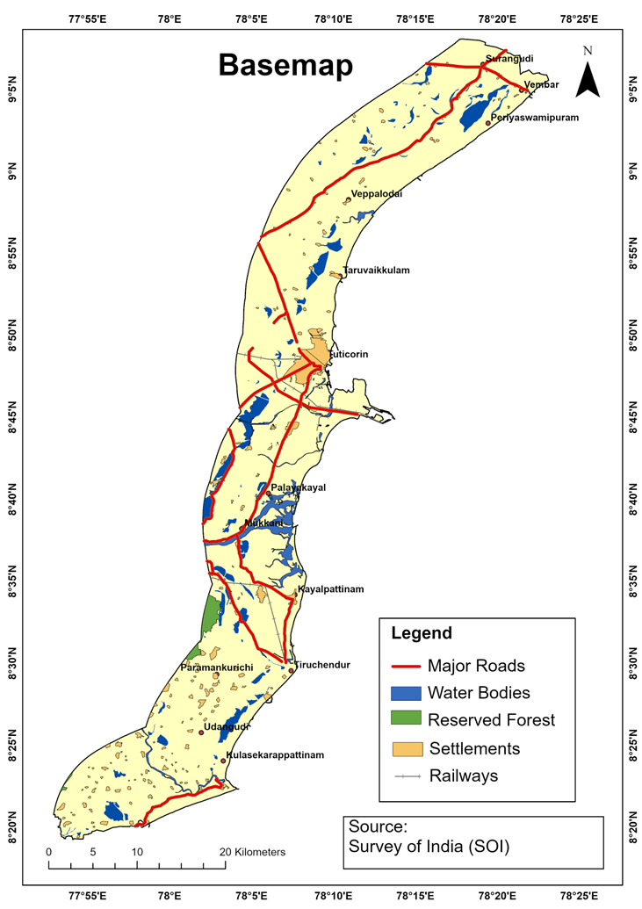

Figure 5.2: Base Map

## DRAINAGE MAP

Drainage maps show the layout of rivers, streams, canals, and catchment areas, which are vital in understanding water flow patterns in a region. The Drainage map is shown in Figure 5.3. Canal, these are artificial channels used for irrigation or navigation. They are represented by thin lines on the map. Streams, these are small, natural watercourses. They are also represented by thin lines but may be distinguished from canals by their more irregular pattern. Rivers, these are larger, natural watercourses. They are shown with thicker lines to indicate their greater size and importance in the drainage network. Based on the map, some of the prominent rivers in the study area appear to be the Thamirabarani River and the Vaipar River. Tanks, these are reservoirs, typically used for water storage. They are represented as small, enclosed polygons.

· 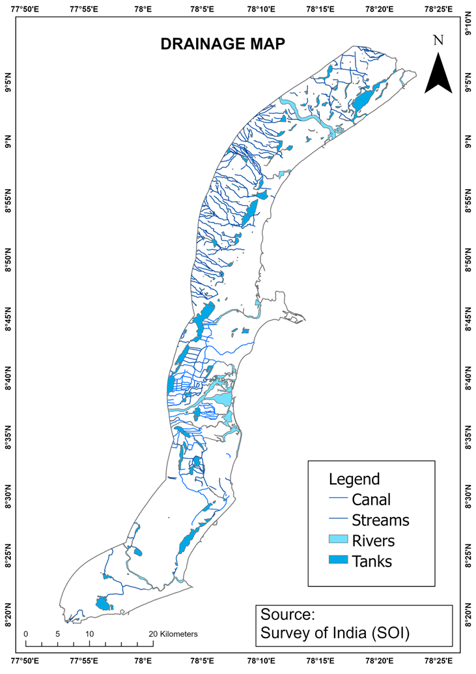

Figure 5.3: Drainage Map

## SLOPE MAP

Coastal slope affects how far sea water can intrude inland during high tides or storm surges. The Slope map is shown in the Figure 5.4.

This slope map categorizes terrain steepness throughout the study area. Dark Green represents areas with slopes of 0-1%, classified as "Nearly Level". These areas are very flat. Light Green represents areas with slopes of 1-3%, classified as "Very Gently Sloping". Yellow represents areas with slopes of 3-5%, classified as "Gently Sloping". Orange represents areas with slopes of 5-10%, classified as "Moderately Sloping". Red represents areas with slopes greater than 10%, classified as "Strongly Sloping". These are the steepest areas shown on the map.

## SOIL MAP

Soil maps represent the spatial distribution, texture, depth, drainage, salinity, and fertility of different soil types. These characteristics influence agricultural productivity, construction suitability, erosion susceptibility, and coastal vegetation. The soil map is shown in the Figure 5.5. This soil distribution map highlights different soil types across the study area. Alluvial soils dominate the central and southern valleys, suggesting deposition from nearby rivers or streams ideal for agriculture. Loamy and clayey soils appear interspersed in the west and central regions, offering a balance of fertility and water retention. Sandy patches are isolated and located mainly in the northwestern fringe, possibly unsuitable for intensive farming. This spatial variation aids land suitability analysis.

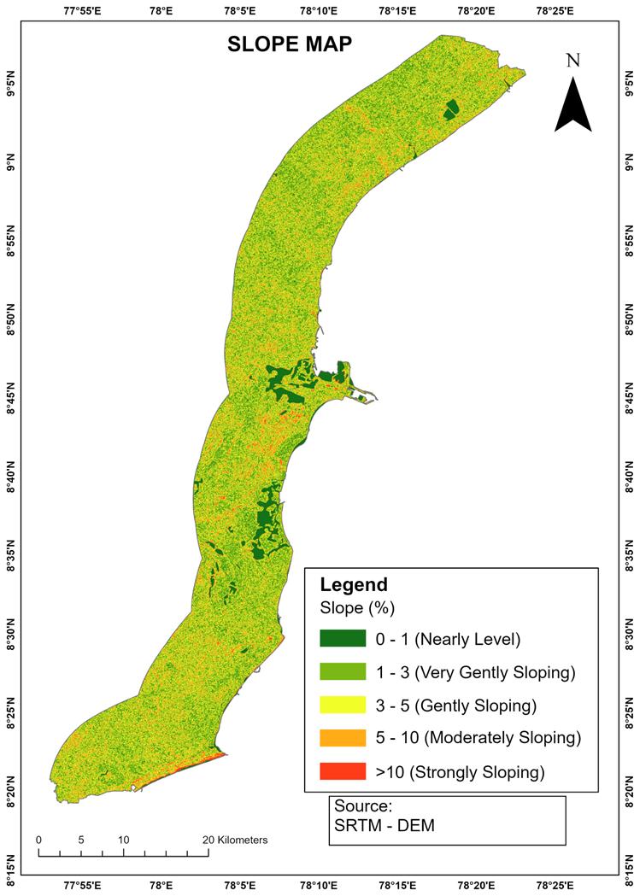

Figure 5.4: Slope Map

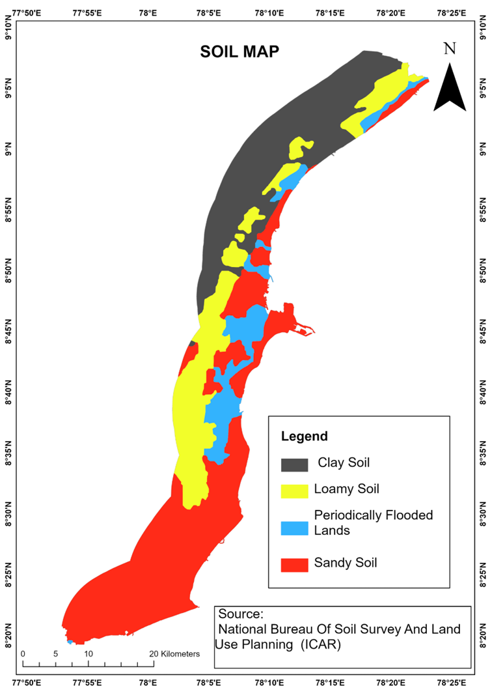

Figure 5.5: Soil Map

## LITHOLOGY MAP

Lithology is critical in coastal studies for assessing the resistance of shoreline material to erosion and weathering. Hard rock coastlines erode slower than sandy or alluvial ones, influencing shoreline stability and change rates. The lithology map is shown in the Figure 5.6.

**Fluvio-marine deposits** dominate the **central corridor**, indicating areas where riverine and coastal processes converge. These regions are likely to support fertile soils through sediment deposition, favoring agriculture and groundwater recharge. **Marine deposits** are widely spread along the **eastern and southeastern coastal belt**, representing regions shaped by coastal sedimentation. These zones are typically flat and may contain saline-prone soils but can support specific coastal land uses. **Fluvial formations** occur in **southwestern and western-central belts**, pointing to areas shaped by river action. These zones are favorable for agriculture due to sediment layering and nutrient-rich profiles. **Hornblende-biotite gneiss** appears in the **northwestern and northeastern hills**, indicating hard rock terrain with limited soil depth and low infiltration capacity. These zones may pose constraints for agriculture or groundwater extraction. **Sandstone with clay** formations are scattered in **southwestern pockets**, offering moderate permeability and water retention capacity, suitable for selective cropping. **Aeolian deposits** are confined to **isolated western and southern parts**, suggesting wind-blown sediments with loose, sandy textures—often unsuitable for intensive agriculture due to poor nutrient holding. **Calc-granulite and limestone** outcrops are minor and localized, contributing to specific mineral-rich zones that may affect soil chemistry and vegetation types.

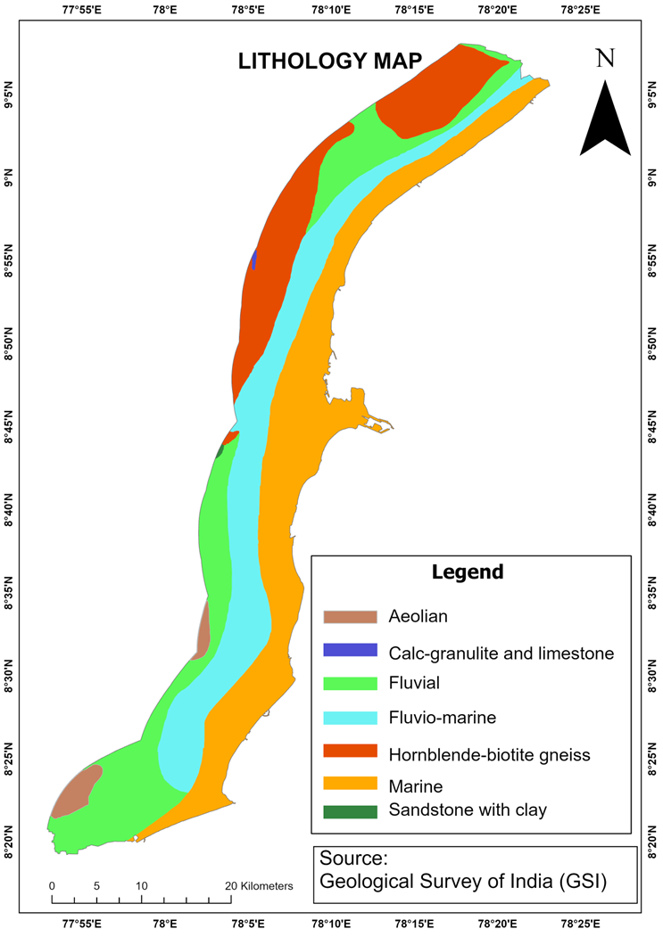

Figure 5.6: Lithology Map

## GEOMORPHOLOGY MAP

Geomorphological maps classify landforms based on surface processes such as coastal erosion, deposition, tidal action, and aeolian activity. These maps identify features like beaches, dunes, estuaries, lagoons, and deltas, which evolve over time due to natural forces. The geomorphology map is shown in Figure 5.7. The geomorphology map illustrates the diverse landforms and geological features of the Tuticorin coastal area. Different colors represent various geomorphological units: Barrier bars and sand dunes are dominant features, serving as natural protective structures against erosion and storm surges. Tidal flats, spits, and estuarine islands are major features influenced by tidal action and sediment deposition, shaping coastal stability and ecosystems. Floodplains and Pedi plains are lesser-affected landforms, experiencing minimal direct impact from coastal changes but contributing to groundwater recharge and land use patterns. Collectively, these features define the dynamic coastal landscape and influence environmental resilience in Tuticorin.

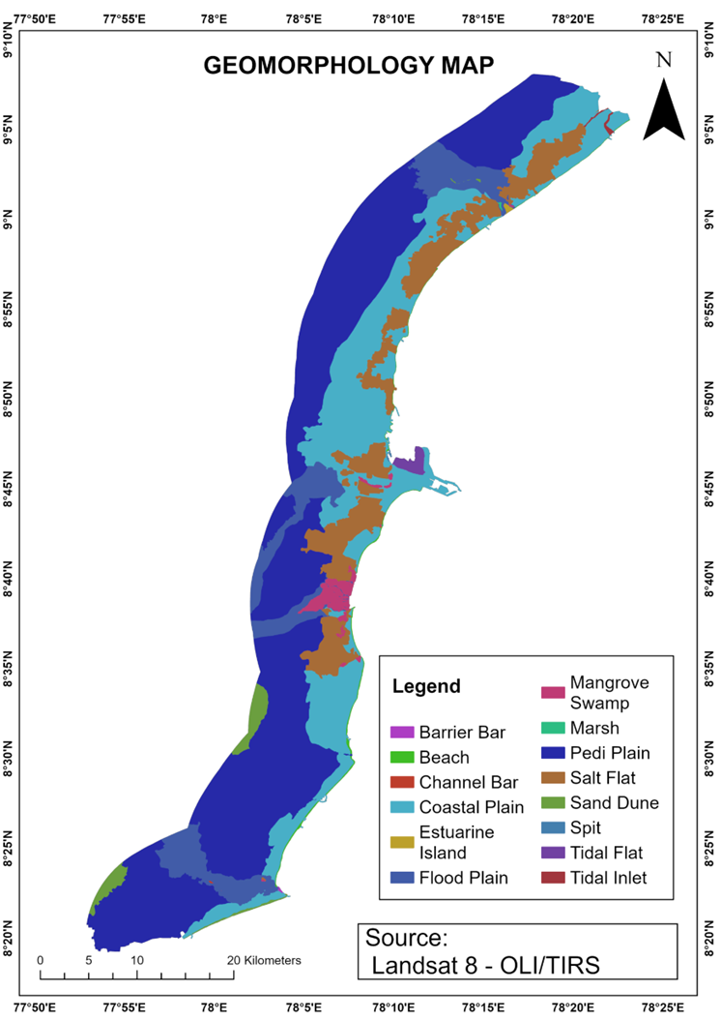

Figure 5.7: Geomorphology Map

## SHORELINE CHANGE

The shoreline and baseline maps form the foundation for analysing coastal dynamics and assessing shoreline change over time. The shoreline map in Figure 5.8 illustrates the spatial position of the coast across five temporal datasets—2005, 2010, 2015, 2020, and 2024 extracted from Landsat 5 (TM) and Landsat 8 (OLI/TIRS) satellite imagery. These historical shorelines are critical for detecting changes due to erosion and accretion along the coast. Complementing this, the baseline map depicts a reference line manually digitized parallel and landward to the general shoreline trend, serving as a static datum from which all shorelines change calculations are performed. When integrated in shoreline analysis tools such as the Digital Shoreline Analysis System (DSAS), transects are cast perpendicularly from the baseline across the various shoreline positions to compute statistical measures such as the End Point Rate (EPR), Net Shoreline Movement (NSM), and Linear Regression Rate (LRR). Together, these maps enable a systematic and quantitative evaluation of shoreline dynamics, which is vital for coastal management and planning.

These maps Figure 5.10 to 5.12 visually represent shoreline change analysis along the southeastern coast of India, particularly in the Thoothukudi district. Each map utilizes a different statistical method—End Point Rate (EPR), Linear Regression Rate (LRR), and Net Shoreline Movement (NSM)—to assess the dynamics of coastal erosion and accretion. The coloured bands along the coast in each map indicate varying degrees of shoreline change, from high erosion to high accretion, using a consistent colour scheme for Interpretability.

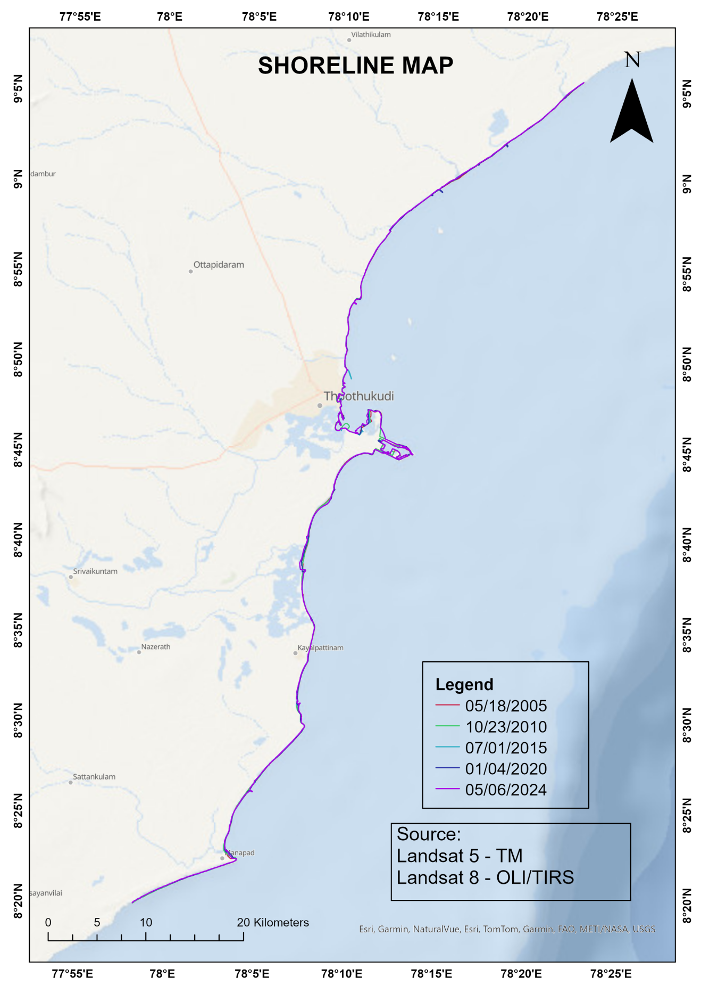

Figure 5.8: Shoreline Map

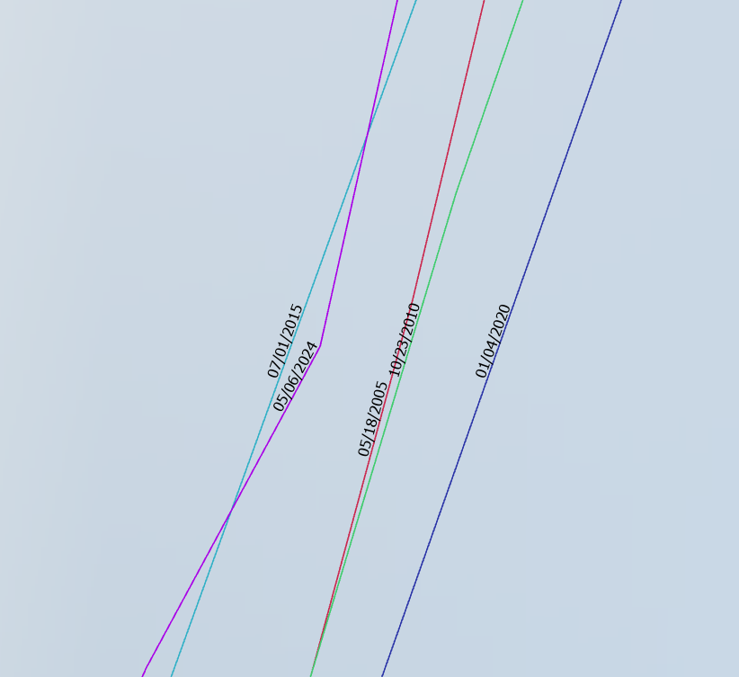

Figure 5.9: Shorelines

The Figure 5.10 illustrates the End Point Rate (EPR), which measures the rate of shoreline change in meters per year by comparing only the oldest and most recent shoreline positions. Areas marked in red represent zones experiencing high erosion (less than -2 meters per year), while dark blue sections signify high accretion (more than 2 meters per year), Orange signify moderate erosion (-2 to -1 m/yr), Yellow signify stable (-1 to 0 m/yr), light blue signify moderate accretion (0 to 1 m/yr) The EPR is useful for understanding long-term trends when only two shoreline data points are available, although it may oversimplify dynamic changes that occurred in between.

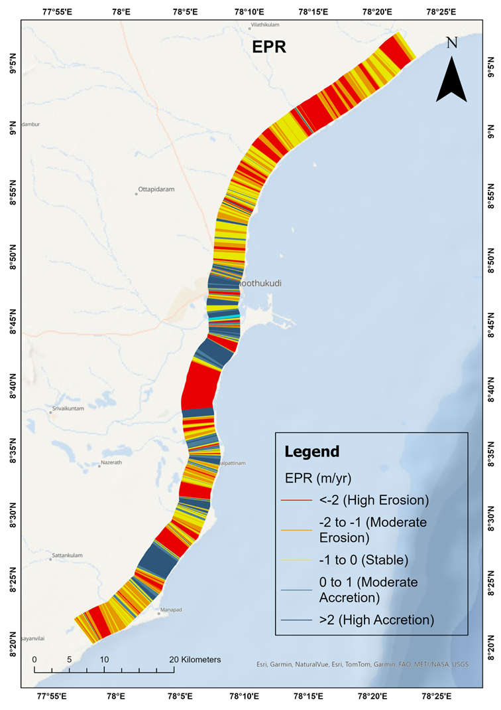

Figure 5.10: EPR Map

**Figure 5.11** illustrates the **Linear Regression Rate (LRR)**, which measures the average rate of shoreline change in meters per year using a best-fit regression line drawn through multiple shoreline positions over time. This method accounts for all available data points, providing a statistically robust estimate of change. Areas marked in red represent zones experiencing high erosion (less than -2 meters per year), while dark blue sections signify high accretion (more than 2 meters per year). Orange indicates moderate erosion (-2 to -1 m/yr), yellow represents stable conditions (-1 to 0 m/yr), and light blue denotes moderate accretion (0 to 1 m/yr). The LRR is particularly valuable for identifying consistent long-term trends by minimizing the influence of short-term variability or outliers.

**Figure 5.12** illustrates the **Net Shoreline Movement (NSM)**, which represents the total horizontal distance in meters that the shoreline has moved between the earliest and most recent positions, without considering the time interval. This measure directly reflects the magnitude of shoreline change. Areas marked in red represent zones of high erosion, where the shoreline has retreated more than 30 meters landward, while dark blue areas show high accretion, where the shoreline has advanced more than 30 meters seaward. Orange indicates moderate erosion (-30 to -15 m), yellow represents stable areas (-15 to 0 m), and light blue signifies moderate accretion (0 to 15 m). NSM is effective for visualizing the cumulative impact of shoreline movement over time, providing a clear picture of total change regardless of the rate.

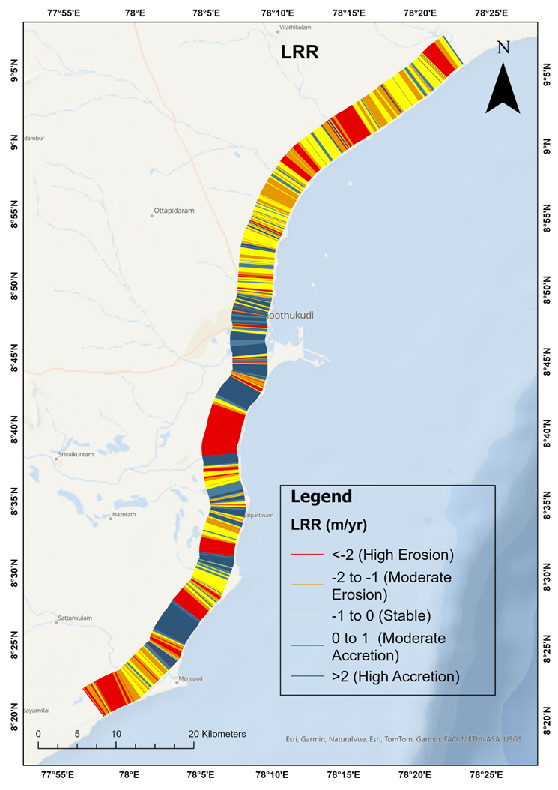

Figure 5.11: LRR Map

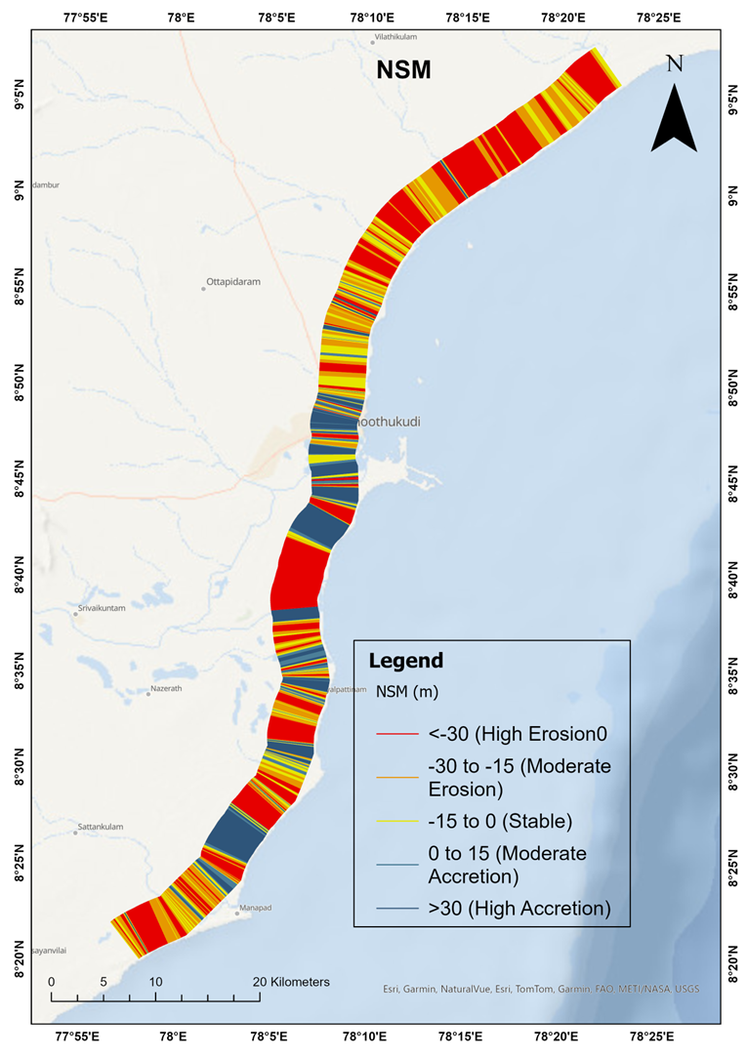

Figure 5.12: NSM Map

Based on the analysis, Vembar to Periyaswamipuram, marked by extensive red and orange zones, especially in the northeastern segment. Significant high erosion is visible, possibly due to coastal currents and lack of natural protection. Veppalodai to Tharuvaikkulam, displays moderate erosion with some patches of stability. Likely impacted by nearshore hydrodynamic processes. South of Tiruchendur to Manapad seen High erosion in the southern segment, particularly close to Kulasekarapattinam and Manapad. Coastal retreat is notable here, indicating severe shoreline changes.

Tuticorin (Thoothukudi) Area, central coastline around Tuticorin shows strong high accretion (dark blue). Likely influenced by port infrastructure and breakwaters altering sediment transport. Kayalpattinam and Tiruchendur, these areas show patches of moderate to high accretion, particularly just north and south of Tiruchendur. Indicates sediment deposition outpacing erosion. Udangudi to Paramankurichi, contains dark and light blue stretches, suggesting substantial coastal build-up. Natural sediment supply or manmade interventions may be contributing factors.

Palayakayal, Mukkani, and parts of Veppalodai show yellow (stable) regions, where shoreline movement is minimal. These zones are neither eroding nor accreting significantly.

The shoreline for 2035 and 2045 were predicted using the DSAS extension tool based on the past shoreline movements. The predicted shorelines were shown in the Figure 5.13, 5.14.

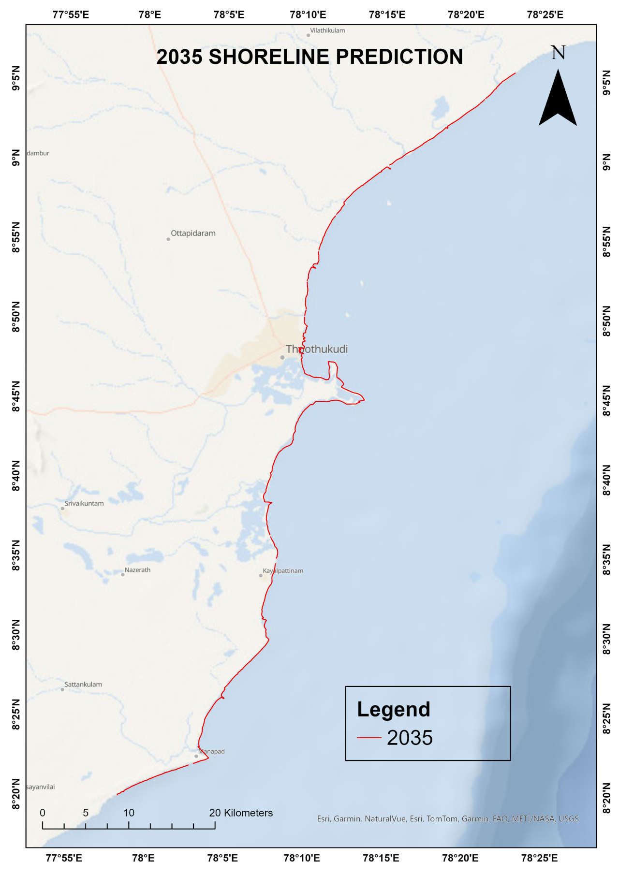

Figure 5.13: 2035 Shoreline Map

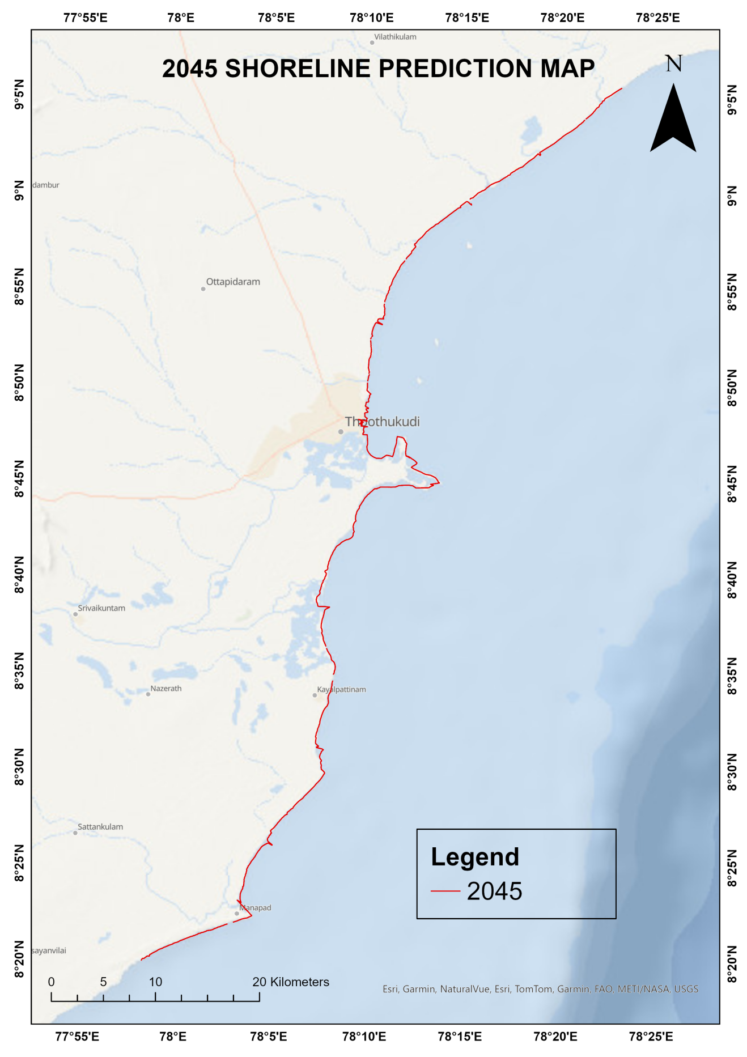

Figure 5.14: 2045 Shoreline Map

In the Kayalpattinam Zone, the projected shoreline movement indicates a landward shift, particularly noticeable between 2024 and 2045. This retreat suggests ongoing coastal erosion, which could pose risks to infrastructure and local livelihoods if unmitigated. The divergence between the shoreline lines across the years clearly indicates that the coast is receding over time, highlighting the need for protective measures in this region.

Conversely, the Vaippar Zone, Tuticorin Zone, demonstrates a seaward shift of the shoreline over the same period. The successive shorelines from 2024 to 2045 move outward, indicating shoreline accretion. This trend implies sediment deposition is dominant here, potentially due to favourable geomorphological conditions or human interventions like groynes or breakwaters, Port development that promote sediment buildup.

In the Manapad Zone, the shoreline projection also shows a seaward movement, although it appears more uniform and linear compared to Vaippar. The consistent spacing between the predicted shorelines for 2024, 2035, and 2045 suggests a steady accretion pattern, possibly indicating that this zone is experiencing less variability in coastal dynamics and might be more stable than others.

Major accretions were seen in the Tuticorin coast due to development of Port and Trichendur Coast due to the developing structures like groynes.

## LANDUSE&LAND COVER CHANGE DETECTION

The 2005 LULC map shown in Figure 5.15, shows a landscape dominated by land with scrub, cropland, and rural areas, interspersed with patches of urban settlements and water bodies. Urban areas were relatively limited in extent. The coast was flanked by mangroves, mudflats, and saltpans, indicating ecological richness and dependence on traditional livelihoods like salt production and fishing.

By 2015, urban sprawl had significantly expanded, especially around mid-coastal regions, consuming parts of rural and cropland areas. Mangroves and natural vegetation saw slight reductions, indicating early signs of habitat loss. The increase in saltpan and plantation areas also reflects land use pressure and economic exploitation of coastal lands as shown in Figure 5.16.

The 2024 LULC map Figure 5.17, shows accelerated urban expansion, particularly around Tuticorin city and southern parts like Kayalpattinam and Manapad. Urban land cover has encroached further into agricultural lands, rural zones, and ecologically sensitive areas such as mangroves and fallow land. The growth of cropland and plantation areas is modest, while mangrove coverage has not recovered, indicating continued ecological degradation if interventions are not made.

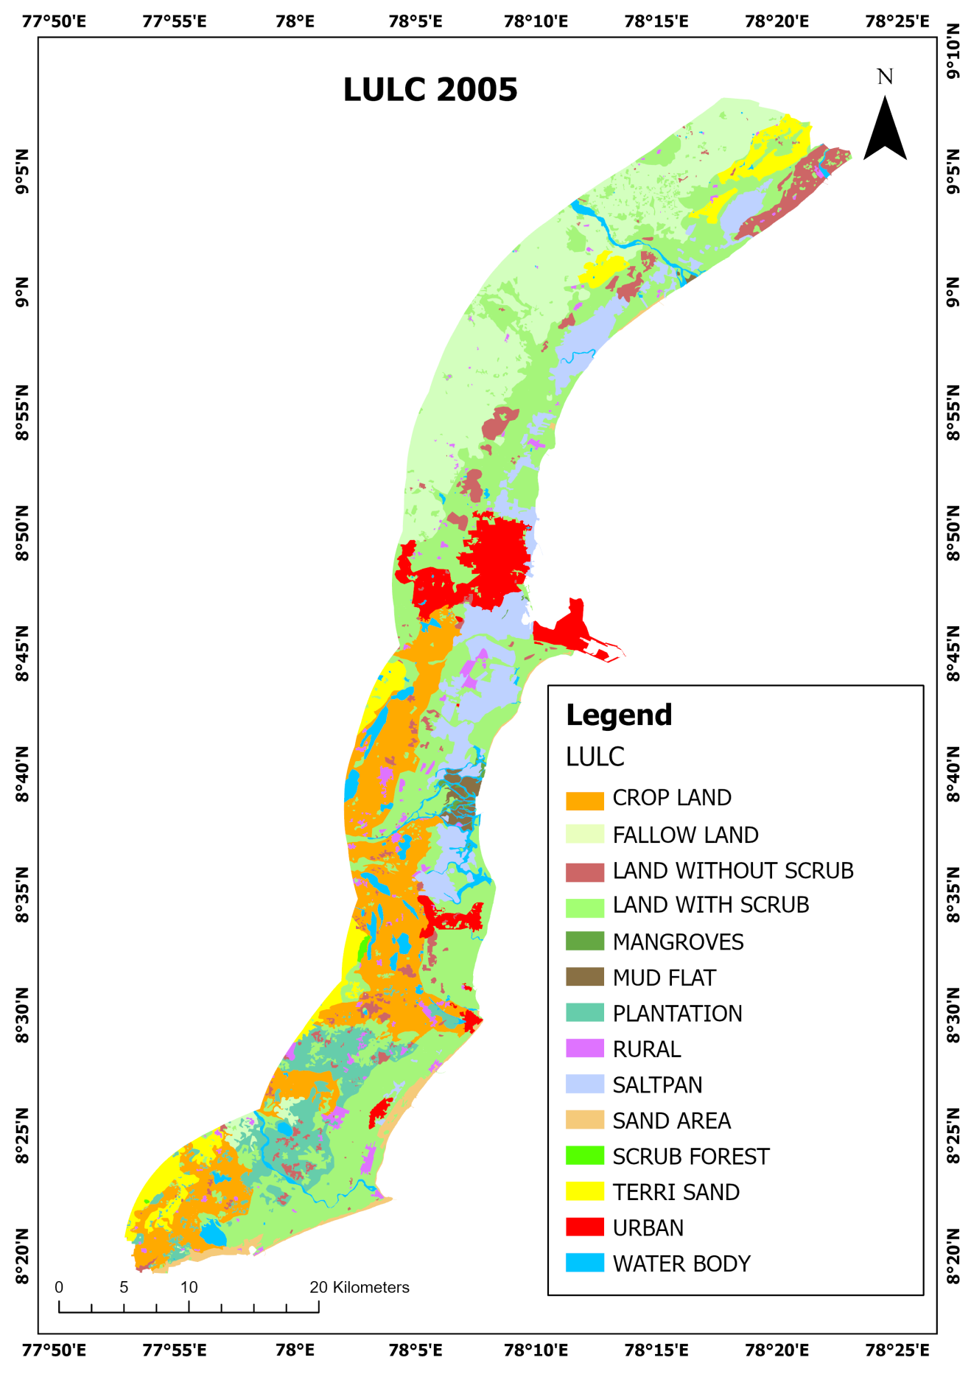

Figure 5.15: 2005 LU/LC Map

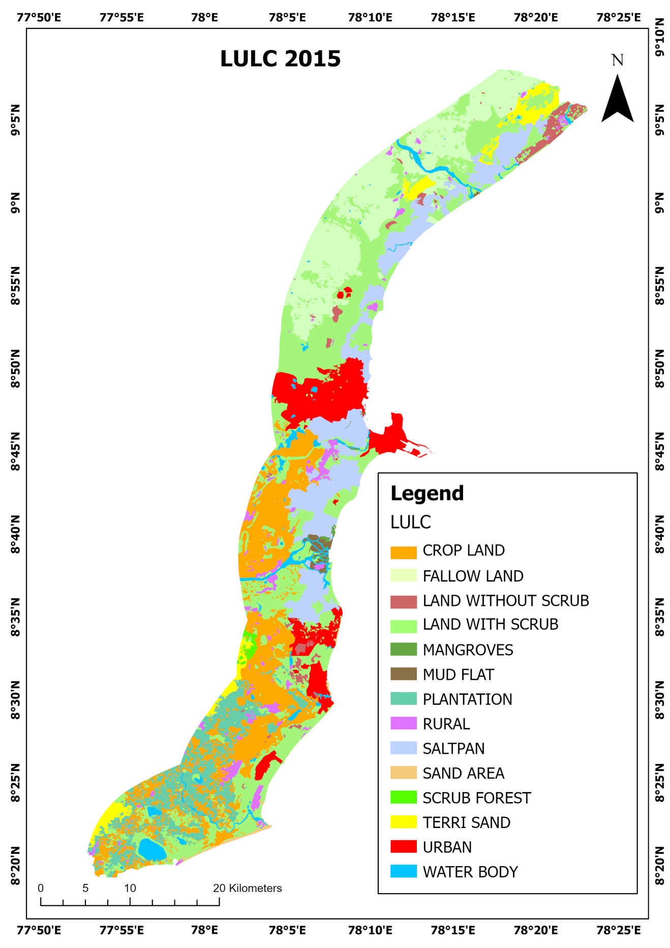

Figure 5.16: 2015 LU/LC map

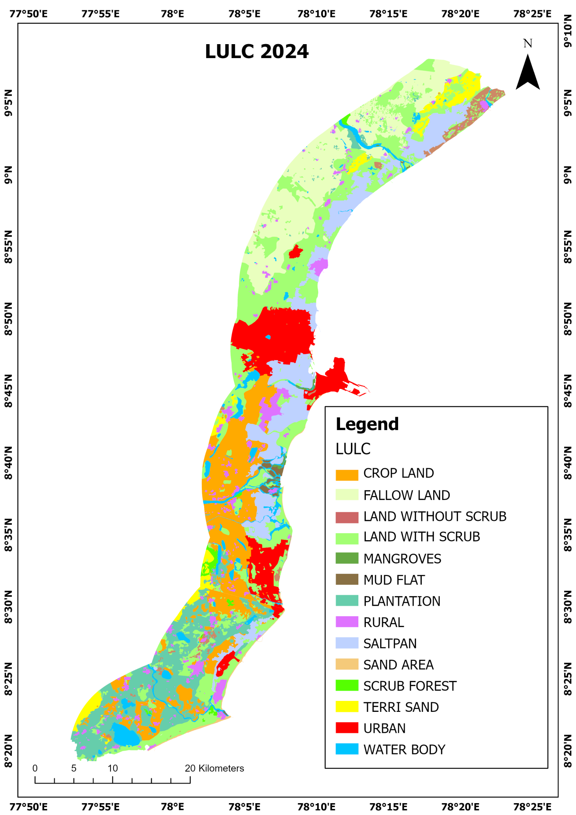

Figure 5.17: 2024 LU/LC Map

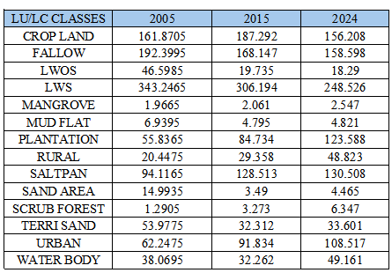

Table 5.1: LU/LC Area Calculation

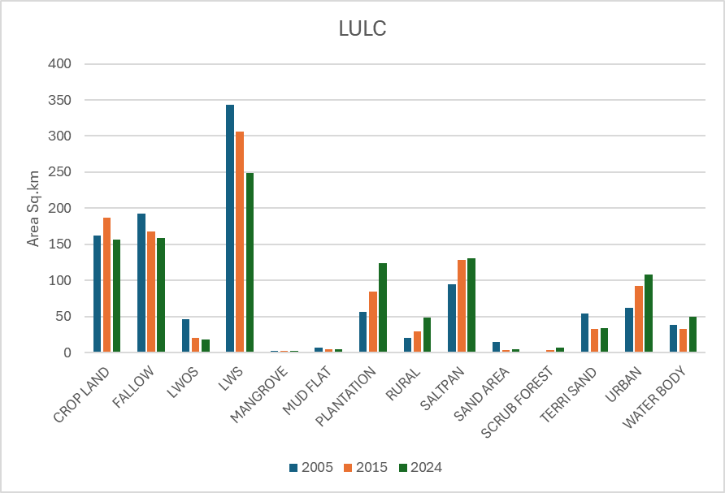

Figure 5.18: LU/LC Change Detection Graph

The Land Use/Land Cover (LULC) data across the years 2005, 2015, and 2024 (with area in sq. km) indicates significant changes in land utilization patterns over the past two decades. Cultivation land increased from 161.87 sq.km in 2005 to 187.29 sq.km in 2015, followed by a decrease to 156.21 sq.km in 2024, suggesting early agricultural intensification later offset by conversion to urban or plantation land. Fallow land steadily declined from 192.40 sq.km to 158.60 sq.km, signalling shrinking periods of agricultural rest. Land without scrub (LWOS) and land with scrub (LWS) both show a continual drop, reflecting degradation or transformation into other land use types, particularly urban or plantation areas. Mangroves saw a slight rise from 1.97 to 2.55 sq.km, pointing to minor ecological recovery efforts.

In contrast, plantation areas expanded significantly from 55.84 sq.km in 2005 to 123.59 sq.km in 2024, highlighting a growing focus on commercial or monoculture crops. Urban land use also increased sharply, nearly doubling from 62.25 sq.km in 2005 to 108.52 sq.km by 2024, emphasizing rapid urbanization. The area under saltpans remained relatively stable, peaking at 130.51 sq.km in 2024, indicating consistent economic activity. Interestingly, rural areas increased from 20.45 sq.km to 48.82 sq.km, possibly due to the growth of rural settlements or reclassification of land. Water bodies also expanded from 38.07 sq.km to 49.16 sq.km, suggesting improved water retention or seasonal fluctuations. Due to the flood in December 2023, there is increase in the waterbodies.

Meanwhile, environmentally sensitive or degraded zones like mud flats, sand areas, and scrub forest exhibit mixed trends. Mud flats decreased and stabilized around 4.8 sq.km, while sand areas drastically reduced from 14.99 sq.km to 4.47 sq.km, potentially from land reclamation. Terri sand dropped initially but increased slightly by 2024, suggesting intermittent disturbances. Scrub forests increased modestly to 6.35 sq.km, showing possible reforestation or ecological attention. Altogether, the data highlights a strong shift toward urbanization and plantation growth at the cost of natural or semi-natural landscapes.

## COASTAL VULNERABILITY INDEX

The Coastal Vulnerability Index (CVI) is a quantitative tool used to assess the relative risk posed by natural and anthropogenic hazards along coastlines. It combines physical, environmental, and socioeconomic parameters such as elevation, shoreline change, wave height, sea-level rise, and population density into a single composite score that indicates the degree of vulnerability a coastal area faces from hazards like erosion, flooding, cyclones, and sea-level rise.

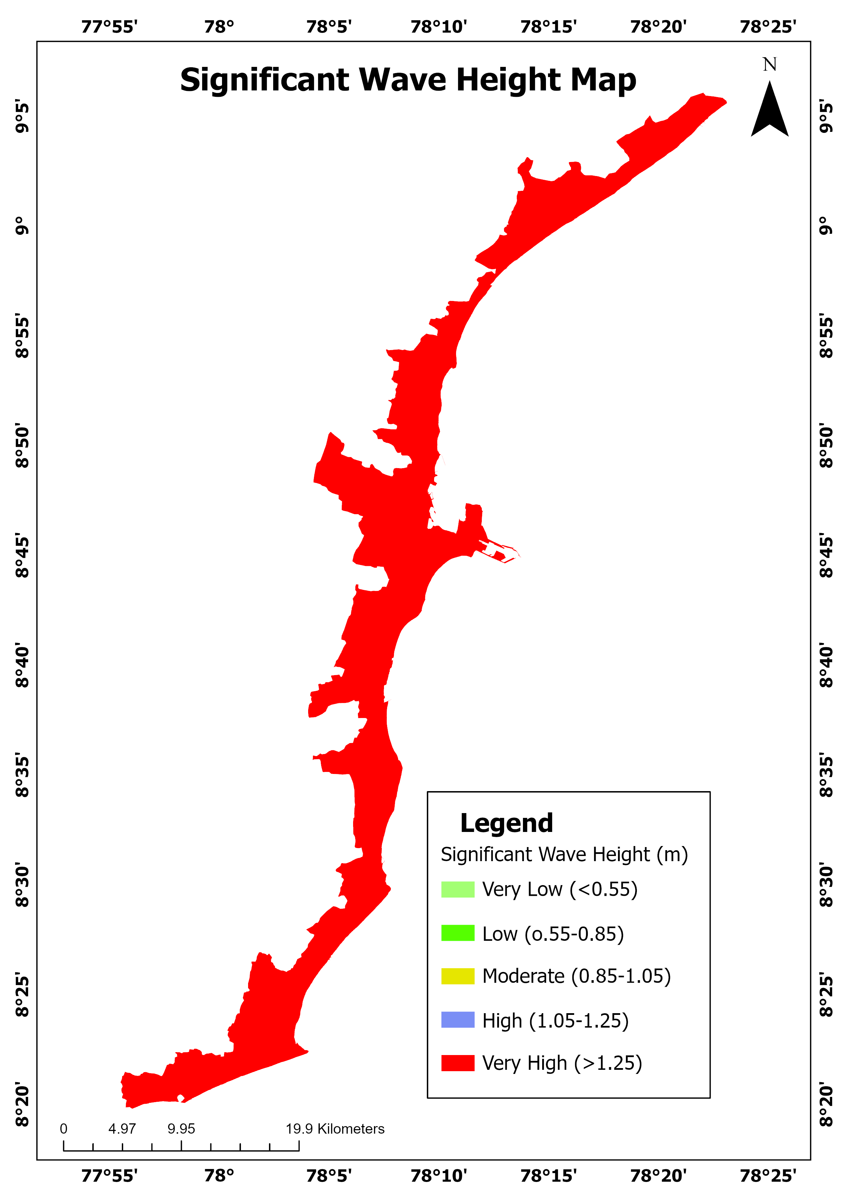

Figure 5.19: Significant Wave Height Map

Wave exposure varies along the coast, with very high wave heights (>1.25 m) impacting open coastal villages like Kayalpattinam, Tiruchendur, and Manapad, exposing them to severe erosional forces.

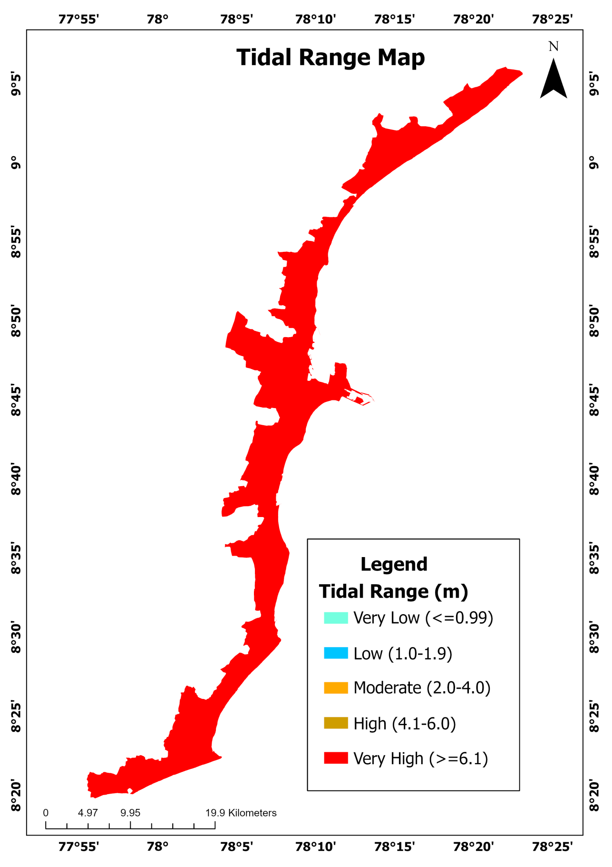

Figure 5.20: Tidal Range Map

Tidal variation data indicates very high tidal ranges (≥6.1 m) near Manapad and Tiruchendur, potentially intensifying flood risks.

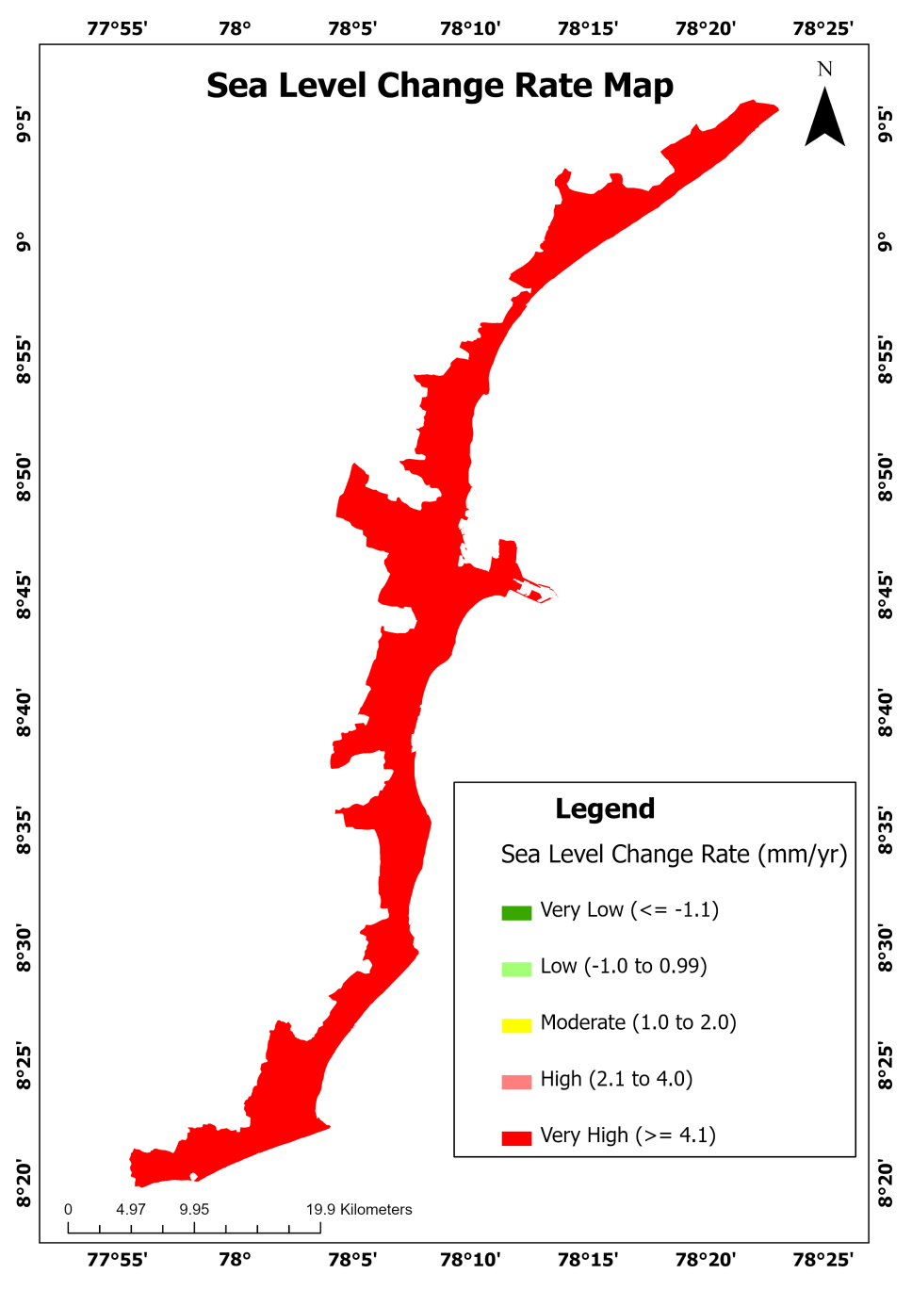

Figure 5.21 : Sea Level Change Rate Map

SLCR trends show **very high-rise rates (≥4.1 mm/yr)** along southern and central villages, especially near **Udangudi** and **Kayalpattinam**, suggesting long-term submergence risk.

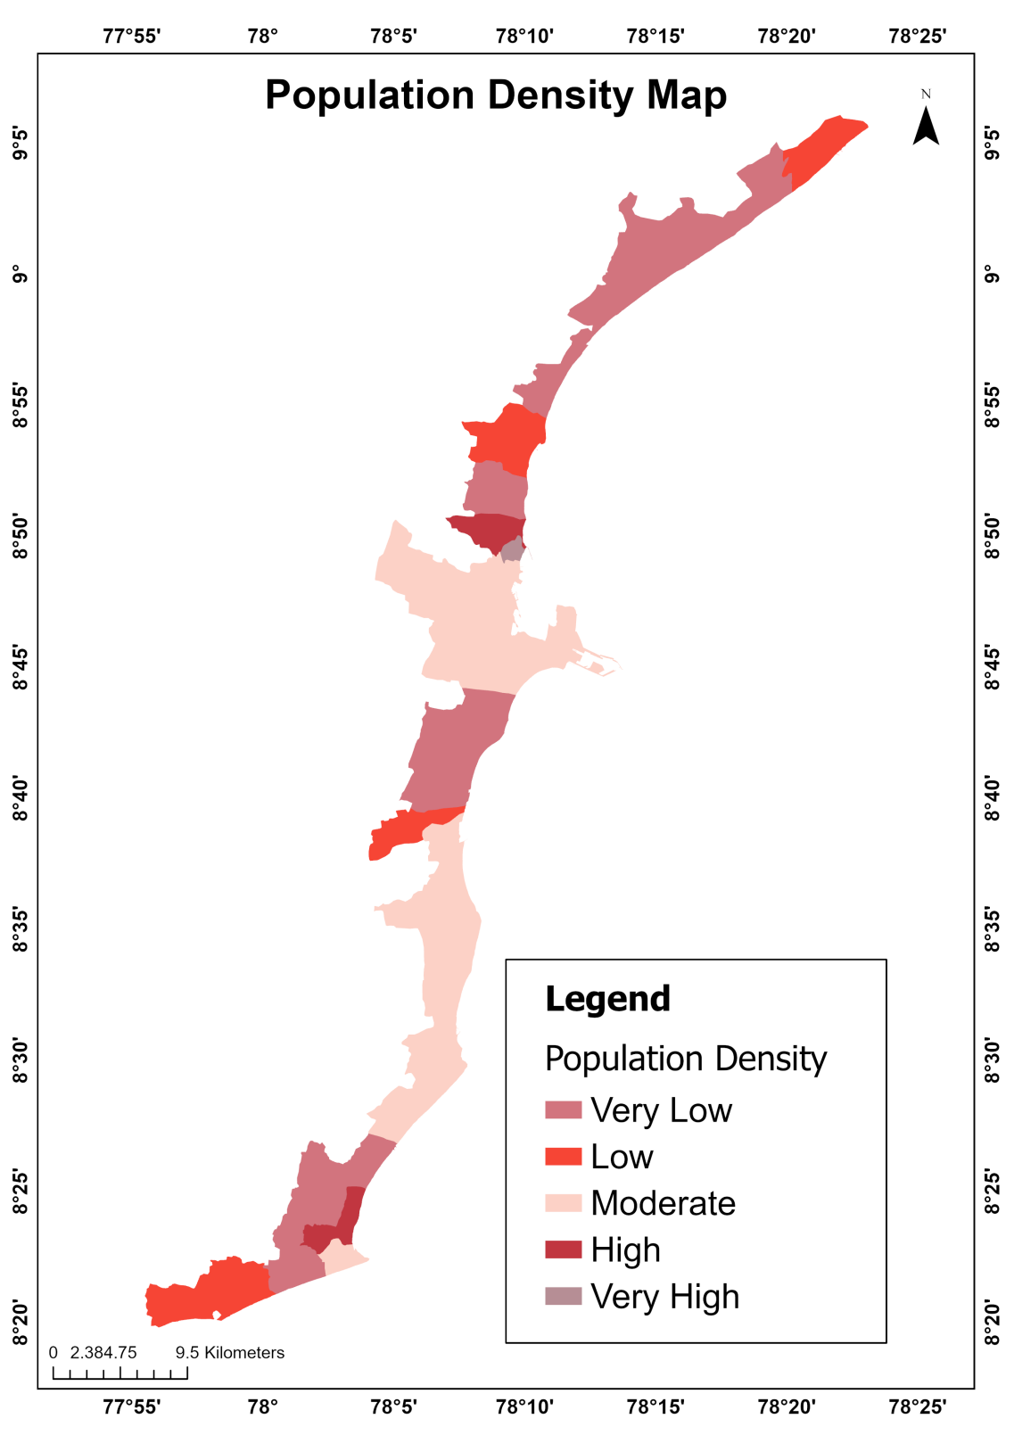

Figure 5.22: Population Density Map

Population densities align with the household pattern, with very high population density in Tuticorin, Tiruchendur, and surrounding peri-urban belts. Moderate densities span semi-urban fringes like Palayakayal, while low population zones appear inland and in the southern belt (e.g., Manapad, Kulasekarapattinam). These metrics indicate direct human exposure in CVI weighting.

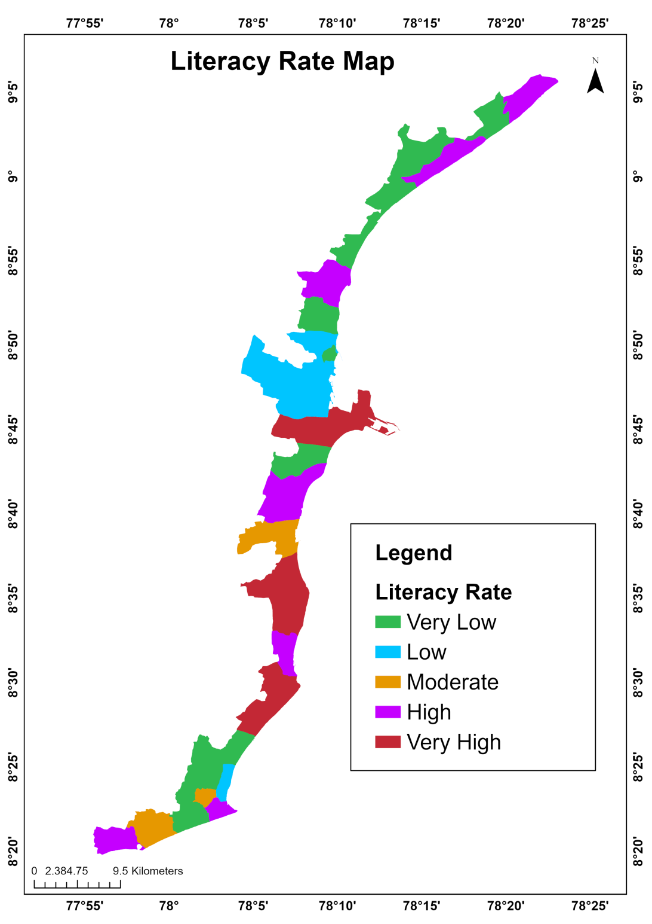

Figure 5.23: Literacy Rate Map

Spatial literacy distribution indicates **very high literacy rates** in **Tuticorin**, **Tiruchendur**, and **Udangudi**, potentially signifying better adaptive capacity. **Low to moderate literacy** zones cover **Veppalodai**, **Surangudi**, and parts of **Manapad**, possibly correlating with lower socio-economic resilience. This metric helps weigh community awareness, preparedness, and long-term adaptation prospects

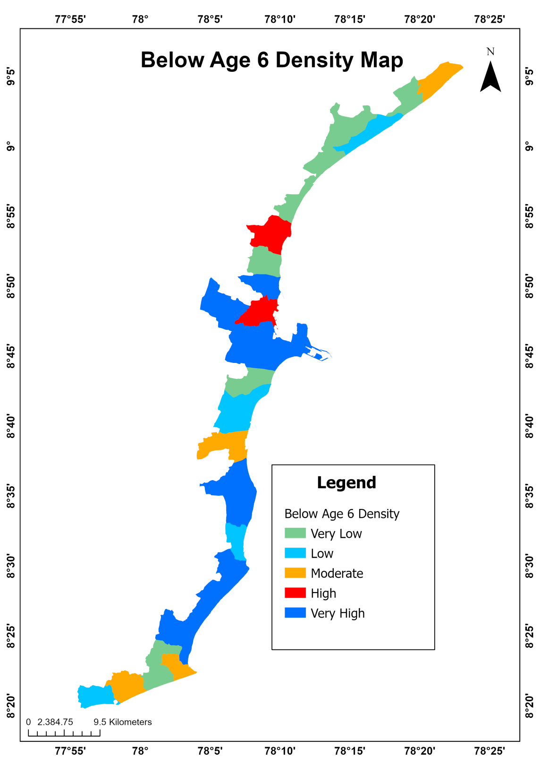

Figure 5.24: Below Age 6 Density Map

Villages such as Manapad, Udangudi, Kayalpattinam, Paramankurichi, and Tuticorin fall under the Very High and High-density categories. These regions are characterized by a large concentration of young children, increasing their vulnerability index score due to the limited physical mobility, dependence on caregivers, and heightened health risks among this age group. In CVI assessment, these areas warrant prioritization for child-specific disaster preparedness measures, such as accessible shelters, pediatric healthcare facilities, and early-warning dissemination systems.

On the other hand, villages like Periyaswamipuram, Surangudi, and parts of Tiruchendur show Very Low to Low densities. While these regions may reflect lower direct child-related vulnerability, the overall CVI still depends on intersecting factors like infrastructure quality, economic dependence, and environmental exposure. Villages including Vembar, Veppalodai, Mukkani, and Kulasai (Kulasekarapattinam) exhibit Moderate child density, representing a balanced vulnerability profile in terms of age-dependent exposure. These zones may benefit from targeted but proportionate resilience planning that supports both adult and child populations during coastal disasters.

Household density clusters strongly around Tuticorin, Kayalpattinam, and Tiruchendur, with these towns marked as very high-density areas. This reflects increased infrastructure, population concentration, and resource stress. Moderate household densities occur in Paramankurichi and Udangudi, whereas low density zones are visible in Veppalodai, Surangudi, and Manapad, indicative of sparse habitation or smaller village scales. These densities are a proxy for population exposure in CVI calculations.

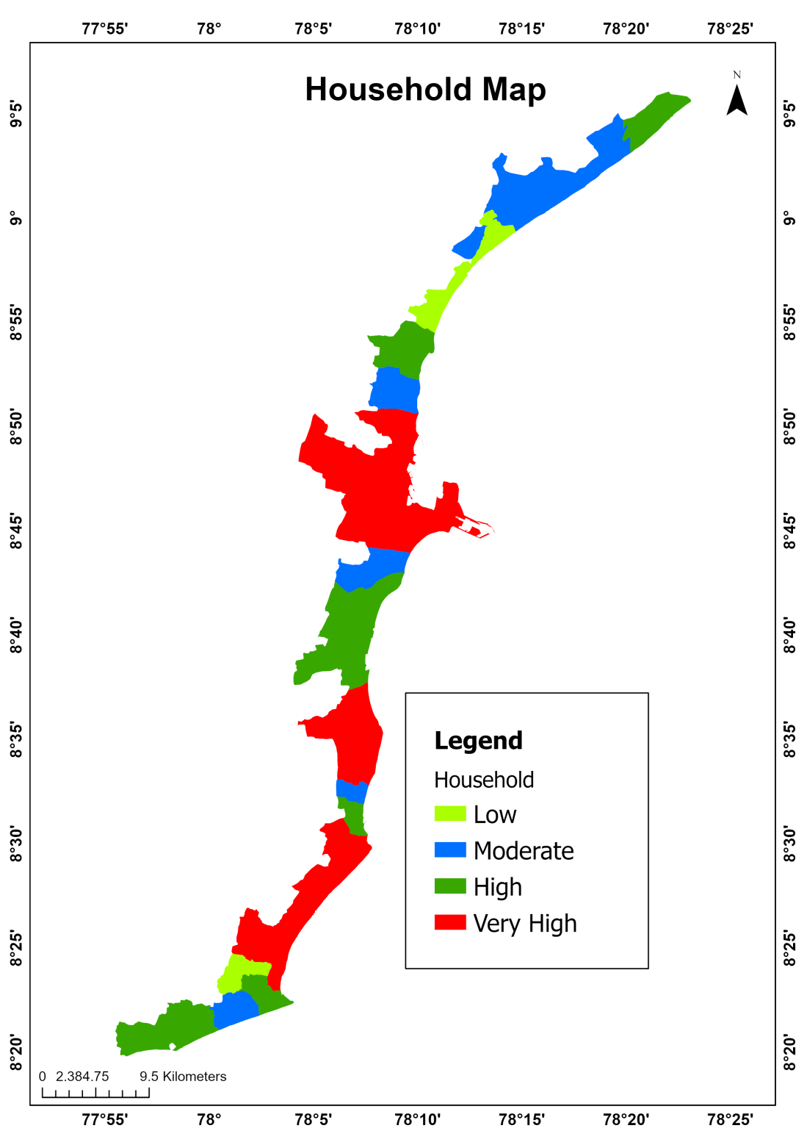

Figure 5.25: Household Map

The CVI assessment for the coastal villages of Tuticorin incorporates a range of physical, environmental, and social parameters to evaluate coastal vulnerability. Physical factors such as Significant Wave Height, Tidal Range, and Shoreline Change Rate (SLCR) highlight the coastal exposure across villages. Locations like Tiruchendur, Manapad, and Kayalpattinam experience high wave action and ongoing shoreline erosion, indicating increased risk. Additionally, topographical factors—notably Elevation and Slope—point to heightened vulnerability in low-lying and gently sloping villages such as Tuticorin, Udangudi, and Kulasai, which are more susceptible to inundation and flooding during extreme weather events.

Social parameters such as Household Density, Literacy Rate, Population Density Map (PDM), and Below Age 6 Density further intensify vulnerability. Highly populated areas with lower literacy rates and a large proportion of children under six—especially Tuticorin, Tiruchendur, and Kayalpattinam—face compounded risks due to limited adaptive capacity and higher exposure.

Based on the integrated CVI approach, villages like Tuticorin, Manapad, Kayalpattinam, and Tiruchendur fall into the high to very high vulnerability categories due to the combined influence of intense physical exposure, ecological stress, and social sensitivity. Conversely, areas such as Surangudi, Vembar, and Periyaswamipuram demonstrate lower vulnerability thanks to higher elevation, better socio-economic indicators, and reduced shoreline change. This comprehensive evaluation provides a spatially explicit tool for prioritizing coastal risk management and resilience planning in the face of climate variability and developmental pressures.

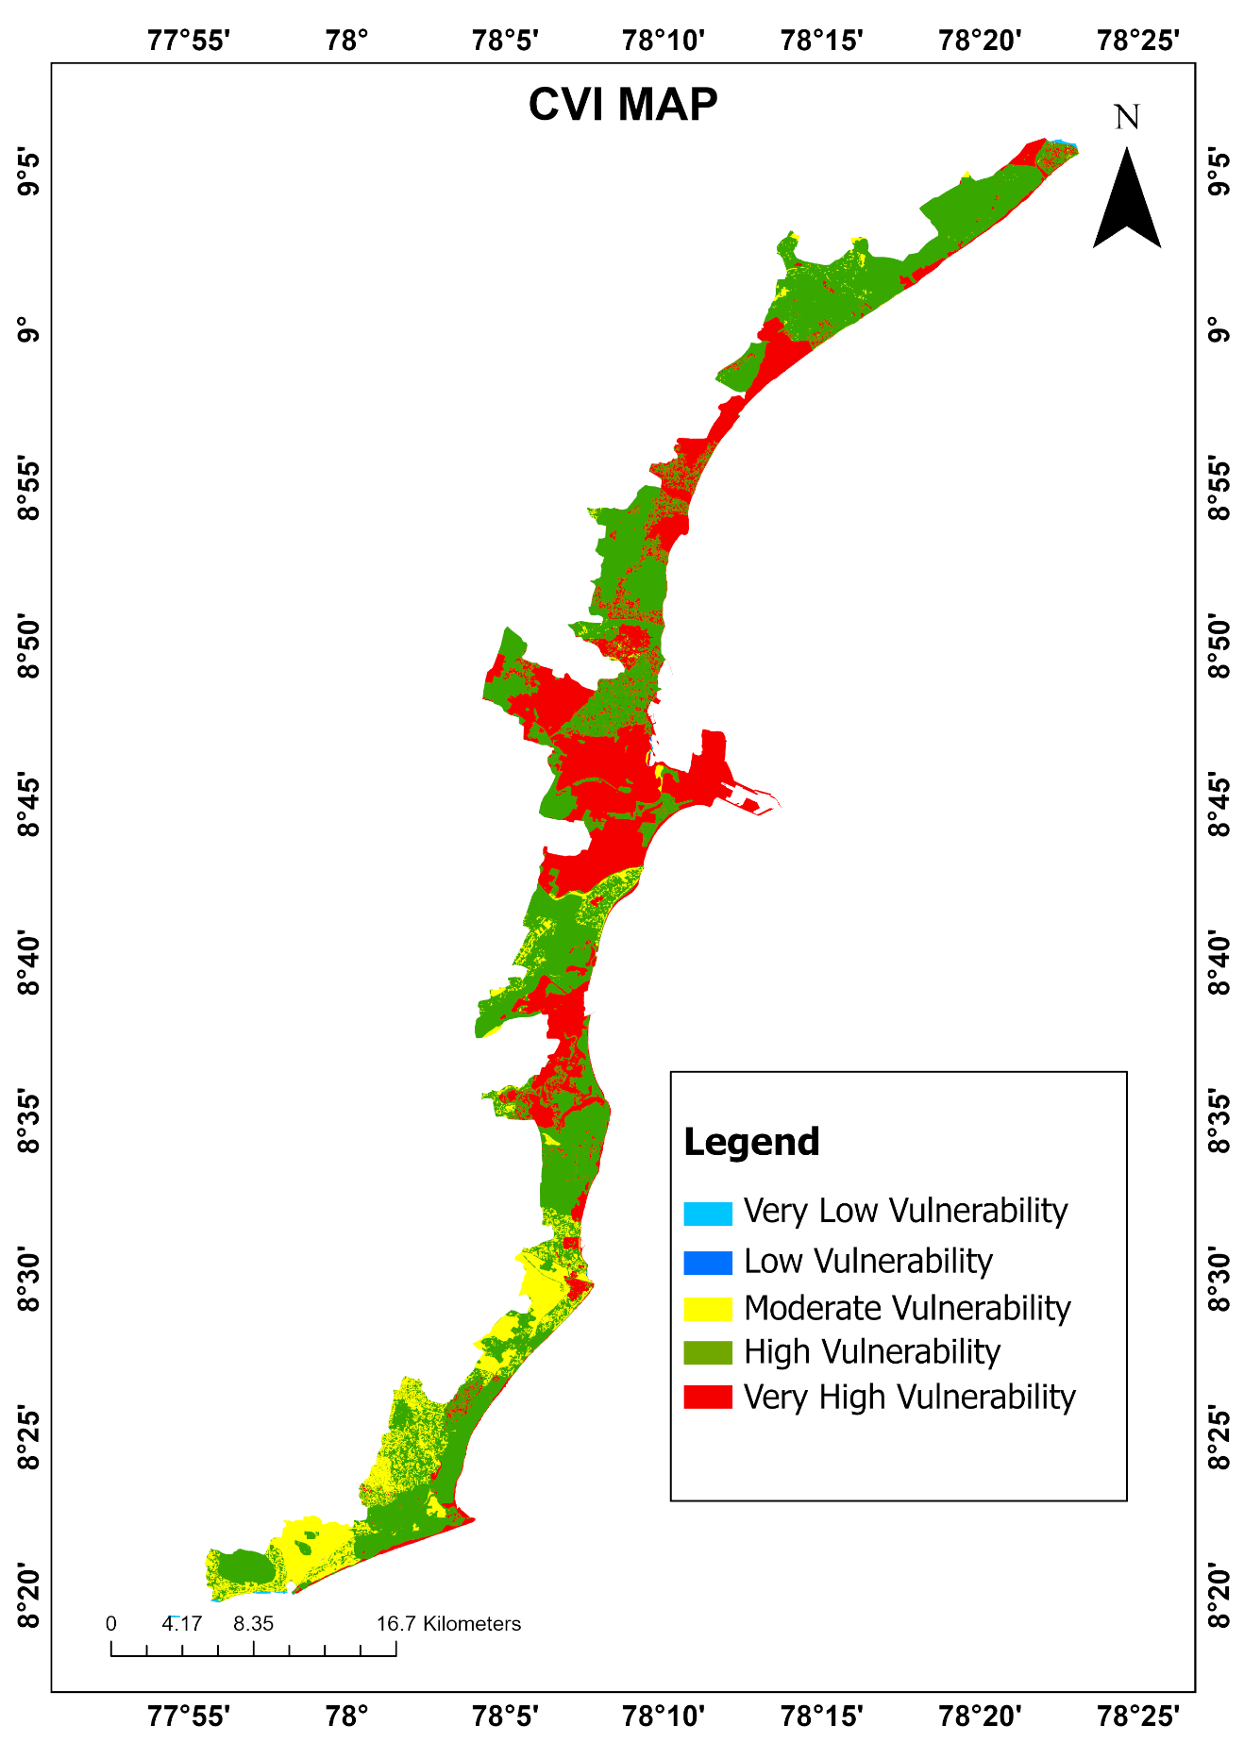

Figure 5.26: Coastal Vulnerability Index Map

## CONCLUSION

Shoreline analysis revealed both high erosion (Manapad) and accretion (Tuticorin Port, Tiruchendur). LU/LC maps show rapid urban expansion and plantation growth, replacing natural features like scrub and cropland. CVI analysis identified high vulnerability in areas with low elevation, high population density, and intense wave action. Future projections show worsening trends, urging immediate intervention.

**CHAPTER 6**

# CONCLUSION

The present study shows that the shoreline dynamics of the Tuticorin coast over the 2005–2024 period exhibit a fluctuating pattern of erosion and accretion, with some areas retreating rapidly while others show sediment build-up. Using DSAS metrics like EPR, LRR and NSM, critical erosion was detected in zones such as Hare Island, Manapad, and the Vembar-Tharuvaikulam stretch. These changes are largely influenced by wave energy, coastal currents, and reduced sediment supply. Shoreline projections for 2035 and 2045 indicate worsening retreat in high-erosion areas, underscoring the urgent need for coastal management interventions. Strategies such as dune restoration, breakwaters, and sediment budgeting can mitigate erosion.

The Landuse/Land Cover (LU/LC) analysis and Coastal Vulnerability Index (CVI) together reveal significant environmental and risk-related changes along the Tuticorin coast. Rapid urbanization and expansion of plantations over the past two decades have replaced natural areas like scrublands, croplands, and mangroves, weakening the coast’s ecological buffer. These land changes, combined with CVI factors such as shoreline erosion, low elevation, wave height, and socio-economic vulnerability, identify high-risk zones. Urbanized, low-lying regions like Tuticorin, Kayalpattinam, and Tiruchendur are especially vulnerable. High population density, low literacy, and young age groups increase exposure in these areas.

# CHAPTER 7

# RECCOMENDAIONS

Based on the spatiotemporal analysis conducted for the Tuticorin coast, it is evident that significant shoreline changes, including both erosion and accretion, have occurred over the past two decades. To mitigate further degradation and enhance coastal resilience, targeted and multi-pronged interventions are necessary. One of the most urgent priorities is to stabilize critical erosion zones such as Hare Island, Vembar, Manapad, and the Vembar–Tharuvaikulam stretch. These areas have exhibited alarming rates of shoreline retreat, as demonstrated by metrics like the End Point Rate (EPR), Linear Regression Rate (LRR), and Net Shoreline Movement (NSM). Nature-based solutions like bio-shielding using vegetation—such as Casuarina and mangrove species can help reduce wave energy and bind coastal sediments. Additionally, engineering measures such as offshore breakwaters, geotextile sand-filled containers, and submerged reefs should be employed where erosion is severe. In port areas like Tuticorin, where sediment transport is disrupted, sand bypassing systems can be installed to mimic natural littoral drift and restore beach balance.

Mangrove ecosystems along the coast have seen only minimal recovery, despite their vital role as buffers against erosion, storm surges, and saline intrusion. Mangrove restoration should be treated as a community-driven priority. Expanding mangrove buffer zones, especially near Kayalpattinam and Palayakayal, can provide both ecological and economic benefits. Local fishing communities should be involved in mangrove nursery development, plantation activities, and long-term monitoring. Government and private stakeholders could support this through payment for ecosystem services (PES) schemes, thereby creating sustainable incentives for conservation.

The analysis of land use and land cover (LULC) changes from 2005 to 2024 reveals a marked shift toward urbanization, often at the cost of cropland, scrublands, and ecologically sensitive zones like mangroves. To combat unplanned expansion, coastal buffer zoning must be implemented to restrict construction within 500 meters of the high tide line. Encouraging vertical development in existing urban cores will reduce pressure on open coastal spaces. Environmental Impact Assessment (EIA) should be made mandatory for any proposed construction within medium- to high-vulnerability zones as identified in the Coastal Vulnerability Index (CVI). Moreover, promoting eco-sensitive tourism and nature-based recreational projects instead of land-intensive resorts can generate revenue while preserving fragile habitats.

Integrated Coastal Zone Management (ICZM) must be adopted as a unifying strategy that brings together local authorities, scientists, port authorities, and community stakeholders. A regional ICZM plan should guide all coastal development activities, ensuring that shoreline dynamics and vulnerability assessments are central to infrastructure and policy decisions. Real-time shoreline monitoring using drones or satellite imagery, combined with predictive modeling tools like DSAS, can help local governments make data-informed planning decisions. These tools should be linked to district disaster management plans to prioritize early warning systems, evacuation routes, and protective infrastructure in high-risk areas.

Given that the Tuticorin coast is experiencing sea-level rise rates of over 4.1 mm/year in certain zones, new infrastructure must be designed with climate resilience in mind. In low-elevation zones near Tuticorin city, Udangudi, and Kayalpattinam, buildings should be elevated on stilts or constructed using flood-resistant materials. Critical infrastructure such as schools, hospitals, and power stations must be relocated away from high-risk flood zones identified by the CVI. Improvements to drainage and stormwater systems should be made to prevent waterlogging during extreme rainfall or storm surges.

Finally, the role of public awareness and education cannot be overstated. Areas with low literacy and high child population density—such as Tiruchendur and Manapad—require targeted outreach and education campaigns. Early warning systems must be multilingual and accessible, with training provided to residents on disaster preparedness, first aid, and shelter protocols. School-based programs and community volunteer initiatives can foster a culture of preparedness and resilience from the ground up.

In conclusion, the Tuticorin coast faces complex challenges due to both natural and anthropogenic factors. Through a combination of ecological restoration, infrastructure planning, regulatory enforcement, and community engagement, it is possible to reduce vulnerability and ensure the sustainable development of this vital coastal region.

# REFERENCE

1. Abdel Aziz, Khaled Mahmoud. 2024. “Quantitative Monitoring of Coastal Erosion and Changes Using Remote Sensing in a Mediterranean Delta.” Civil Engineering Journa*l* 10(6):1842–62. doi: 10.28991/CEJ-2024-010-06-08.
2. Arun Kumar, A., and Pravin D. Kunte. 2012. “Coastal Vulnerability Assessment for Chennai, East Coast of India Using Geospatial Techniques.” Natural Hazards 64(1):853–72. doi: 10.1007/s11069-012-0276-4.
3. Das, Barnali, and Anargha Dhorde. 2022. “Assessment of Shoreline Change and Its Relation with Mangrove Vegetation: A Case Study over North Konkan Region of Raigad, Maharashtra, India.” International Journal of Engineering and Geosciences 7(2):101–11. doi: 10.26833/ijeg.912657.
4. Dwivedi, Chandra Shekhar, Shiva Teja Pampattiwar, Arvind Chandra Pandey, Bikash Ranjan Parida, Debashis Mitra, and Navneet Kumar. 2023. “Characterization of the Coastal Vulnerability in Different Geological Settings: A Comparative Study on Kerala and Tamil Nadu Coasts Using FuzzyAHP.” Sustainability 15(12):9543. doi: 10.3390/su15129543.
5. Elkafrawy, Sameh B., Manar A. Basheer, Hagar M. Mohamed, and Doaa M. Naguib. 2021. “Applications of Remote Sensing and GIS Techniques to Evaluate the Effectiveness of Coastal Structures along Burullus Headland-Eastern Nile Delta, Egypt.” The Egyptian Journal of Remote Sensing and Space Science 24(2):247–54. doi: 10.1016/j.ejrs.2020.01.002.
6. Hammar-Klose, E. S., Thieler, E. R., & Williams, S. J. (2003). National assessment of coastal vulnerability to sea-level rise: Cape Cod National Seashore, Massachusetts (U.S. Geological Survey Open-File Report 02-233). U.S. Department of the Interior. doi:10.3133/ofr02233
7. Hastuti, Amandangi Wahyuning, Masahiko Nagai, and Komang Iwan Suniada. 2022. “Coastal Vulnerability Assessment of Bali Province, Indonesia Using Remote Sensing and GIS Approaches.” Remote Sensing 14(17):4409. doi: 10.3390/rs14174409.
8. Hossain, Sk Ariful, Ismail Mondal, Sandeep Thakur, and Ayad M. Fadhil Al-Quraishi. 2022. “Coastal Vulnerability Assessment of India’s Purba Medinipur-Balasore Coastal Stretch: A Comparative Study Using Empirical Models.” International Journal of Disaster Risk Reduction 77:103065. doi: 10.1016/j.ijdrr.2022.103065.
9. Kankara, R. S., S. Chenthamil Selvan, Vipin J. Markose, B. Rajan, and S. Arockiaraj. 2015. “Estimation of Long and Short Term Shoreline Changes Along Andhra Pradesh Coast Using Remote Sensing and GIS Techniques.” Procedia Engineering 116:855–62. doi: 10.1016/j.proeng.2015.08.374.
10. Kumar, B. Santhosh, A. Balukkarasu, and K. Tamilarasan. 2019. “Coastal Vulnerability Mapping Using Remote Sensing and GIS Techniques in Tuticorin Coast of Tamil Nadu, India.” Journal of Geography, Environment and Earth Science International 1–12. doi: 10.9734/jgeesi/2019/v20i230100.
11. Muhamed Fasil Chettiyam Thodi, Girish Gopinath, Udayar Pillai Surendran, Pranav Prem, Nadhir Al-Ansari, and Mohamed A. Mattar. 2023. “Using RS and GIS Techniques to Assess and Monitor Coastal Changes of Coastal Islands in the Marine Environment of a Humid Tropical Region.” Water 15(21):3819. doi: 10.3390/w15213819.
12. Mutagi, Sheetal, Arunkumar Yadav, and Chandrashekarayya G. Hiremath. 2022. “Shoreline Change Monitoring of Karwar Coast of Karnataka, India, Using Sentinel-2 Satellite.” Pp. 339–50 in *S*ustainability Trends and Challenges in Civil Engineering. Vol. 162, Lecture Notes in Civil Engineering, edited by L. Nandagiri, M. C. Narasimhan, S. Marathe, and S. V. Dinesh. Singapore: Springer Singapore.
13. Muthusankar, g. Lakshumanan, c. Natesan, Usha. 2021. Multi-Hazard Risk Assessment And Coastal Zone Management. s.l.: Scholars’ Press.
14. Sankari, T. Siva, A. R. Chandramouli, K. Gokul, S. S. Mangala Surya, and J. Saravanavel. 2015. “Coastal Vulnerability Mapping Using Geospatial Technologies in Cuddalore-Pichavaram Coastal Tract, Tamil Nadu, India.” Aquatic Procedia 4:412–18. doi: 10.1016/j.aqpro.2015.02.055.
15. Sathiya Bama, V. P., S. Rajakumari, and R. Ramesh. 2020. “Coastal Vulnerability Assessment of Vedaranyam Swamp Coast Based on Land Use and Shoreline Dynamics.” Natural Hazard*s* 100(2):829–42. doi: 10.1007/s11069-019-03844-5.
16. Sebat, Mirna, and Juliet Salloum. 2018. “ESTIMATE THE RATE OF SHORELINE CHANGE USING THE STATISTICAL ANALYSIS TECHNIQUE (EPR).” Business & IT VIII(1):59–65. doi: 10.14311/bit.2018.01.07.
17. Sheik Mujabar, P., and N. Chandrasekar. 2013. “Coastal Erosion Hazard and Vulnerability Assessment for Southern Coastal Tamil Nadu of India by Using Remote Sensing and GIS.” *Natural Hazards* 69(3):1295–1314. doi: 10.1007/s11069-011-9962-x.
18. Sudha Rani, N. N. V., A. N. V. Satyanarayana, and Prasad Kumar Bhaskaran. 2015. “Coastal Vulnerability Assessment Studies over India: A Review.” Natural Hazards 77(1):405–28. doi: 10.1007/s11069-015-1597-x.
19. Thieler, E. R., & Hammar-Klose, E. S. (1999). National assessment of coastal vulnerability to sea-level rise: Preliminary results for the U.S. Atlantic coast (U.S. Geological Survey Open-File Report 99-593). U.S. Department of the Interior. doi:10.3133/ofr99593
20. Usha Natesan, Anitha Parthasarathy, R. Vishnunath, G. Edwin Jeba Kumar, and Vincent A. Ferrer. 2015. “Monitoring Longterm Shoreline Changes along Tamil Nadu, India Using Geospatial Techniques.” Aquatic Procedia 4:325–32. doi: 10.1016/j.aqpro.2015.02.044.
21. Yadav, A. B., P. C. Mohanty, and A. Singh. 2022. “Coastal Vulnerability Assessment: A Case Study of the Ratnagiri Coast, Maharashtra, India.” IOP Conference Series: Earth and Environmental Science 1032(1):012038. doi: 10.1088/1755-1315/1032/1/012038.